1. **Write a program to check whether an entered number is Prime. Use classes.**
   * **Code:**

#include<iostream.h>

#include<conio.h>

class prime

{ int a, fl;

public:

void input()

{ cout<<"Enter the number.\n";

cin>>a;

}

void calc()

{ int i, r; fl=0;

For (i=2;i<a; i++)

{ r=a%i;

If (r==0)

{ fl=1;

break; }

} }

void output()

{ if(fl==1)

cout<<a<<" is not a prime number.";

else

cout<<a<<" is a prime number.";

}};

void main()

{ prime x;

clrscr();

x.input();

x.calc();

x.output();

}

* + **Output:**

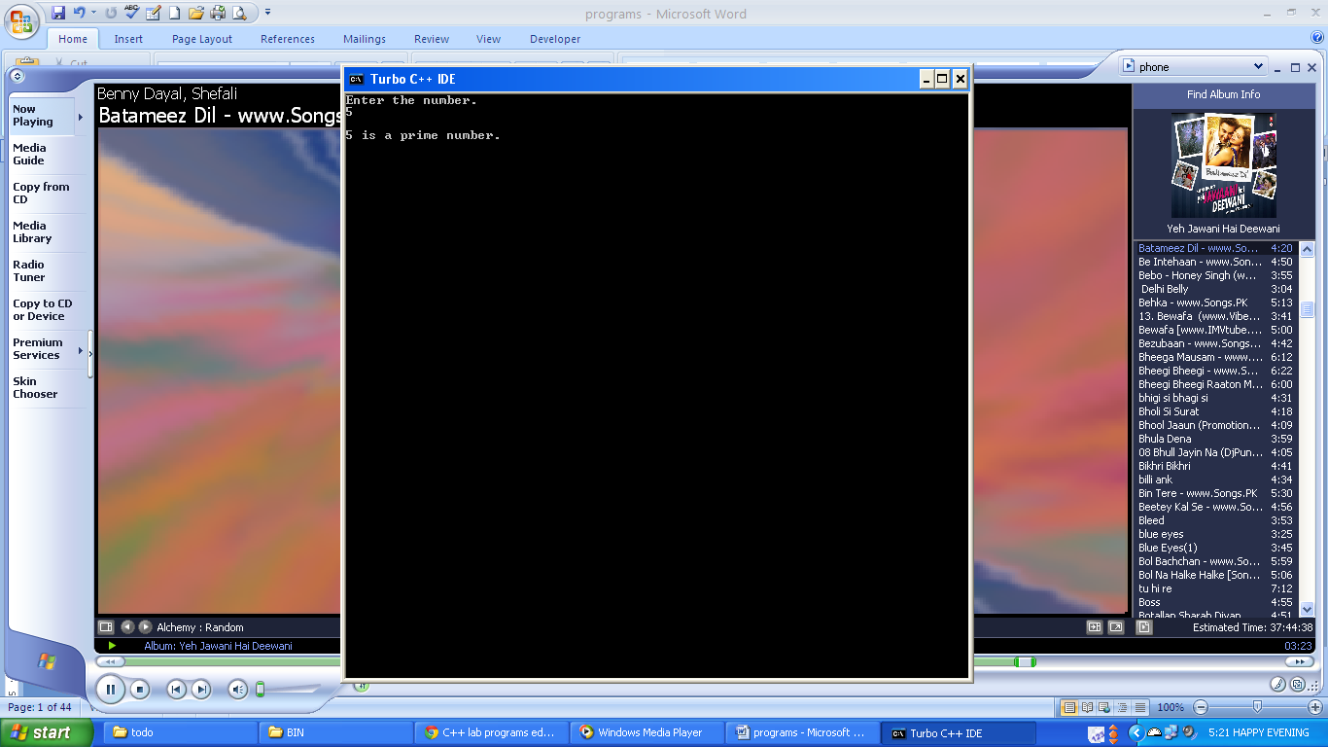

1. **Write a program to check whether an entered number is Prime. Use this pointer to initialize instance variables.**
   * **Code:**

#include<iostream.h>

#include<conio.h>

class prime

{ int a,fl;

public:

void input(int a)

{ this->a=a; }

void calc()

{ int i,r;

fl=0;

for(i=2;i<a;i++)

{ r=a%i;

if(r==0)

{ fl=1;

break;

}

}

}

void output()

{ if(fl==1)

cout<<a<<" is not a prime number.";

else

cout<<a<<" is a prime number.";

}};

void main()

{ prime x;

int b;

clrscr();

cout<<”Enter a number\n”;

cin>>b;

cout<<”\n”;

x.input(b);

x.calc();

x.output();

}

* + **Output:**

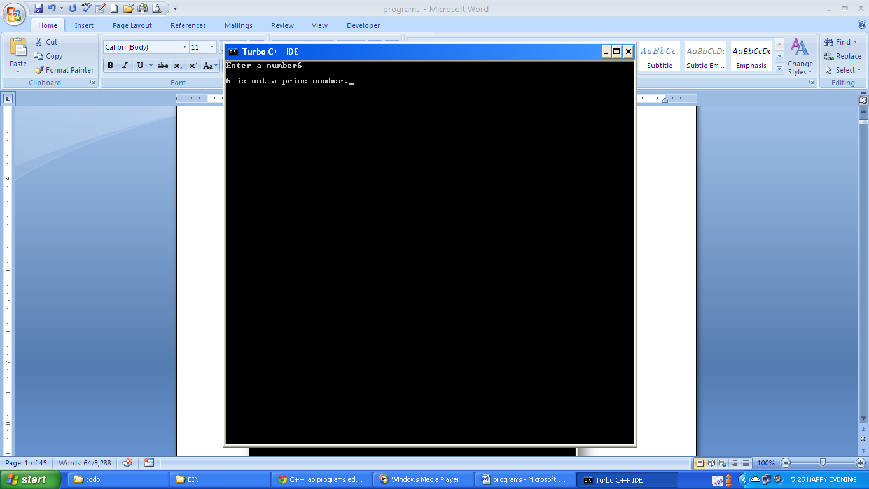

1. **Write a program to check whether an entered number is palindrome. Function checking the status of palindrome must return a value.**
   * **Code:**

#include<iostream.h>

#include<conio.h>

class pal

{ int a;

public:

void input(int a)

{ this->a=a;}

int calc();

void output(int s)

{ if(a==s)

cout<<"\n input no. is palindrome";

else

cout<<"\n input no. is not palindrome";

} };

int pal::calc()

{ int p,m;

int sum=0;

for(m=a;m>0;)

{ p=m%10;

m=m/10;

sum=(sum*10)+p;

}

return sum;

}

void main()

{ clrscr();

int num,q;

pal ob1;

cout<<"enter a number";

cin>>num;

ob1.input(num);

q=ob1.calc();

ob1.output(q);

getch();

}

* + **Output:**

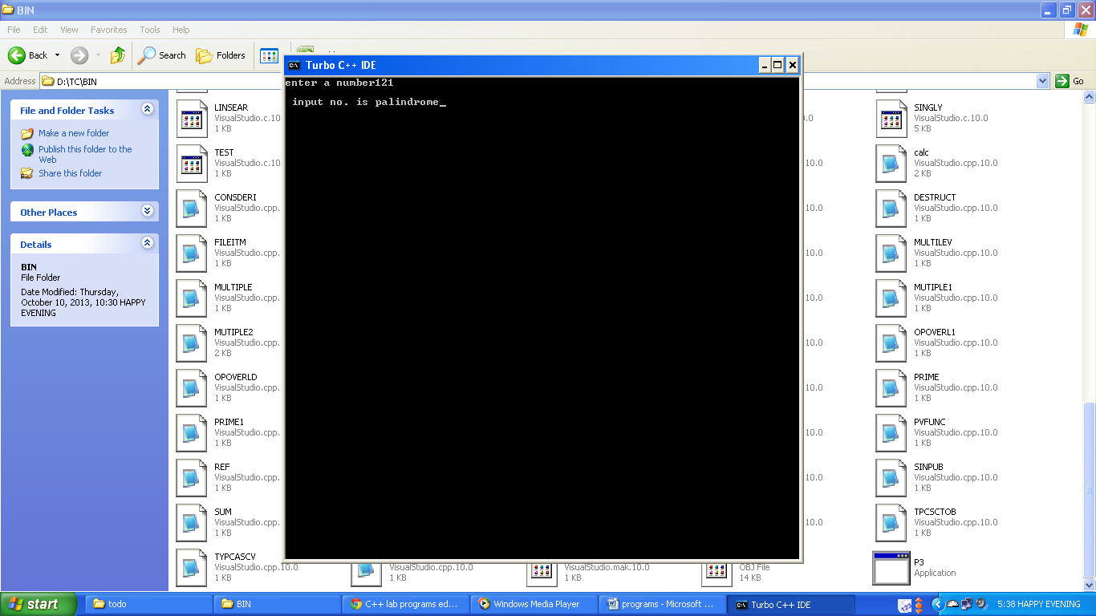

1. **Write a program to add two numbers with the help of constructor overloading. Function calculating addition must return a value.**
   * **Code:**

#include<iostream.h>

#include<conio.h>

class cons_overload

{ double x, y;

public:

cons_overload()

{}

cons_overload(int a,int b)

{ x=a; y=b; }

cons_overload(float a,float b)

{ x=a; y=b; }

cons_overload(double a, double b)

{ x=a; y=b; }

cons_overload(int a,float b)

{ x=a; y=b; }

double add()

{ double c; c=x+y;

cout<<"\nSum of "<<x<<" and "<<y<<" is ";

return c;

}};

void main()

{ double a;

cons_overload ob(3,5);

a=ob.add(); cout<<a;

cons_overload ob1(3.3f,5.5f);

a=ob1.add(); cout<<a;

cons_overload ob2(3.5,5.3);

a=ob2.add(); cout<<a;

cons_overload ob3(3,5.5f);

a=ob3.add(); cout<<a;

}

* + **Output:**

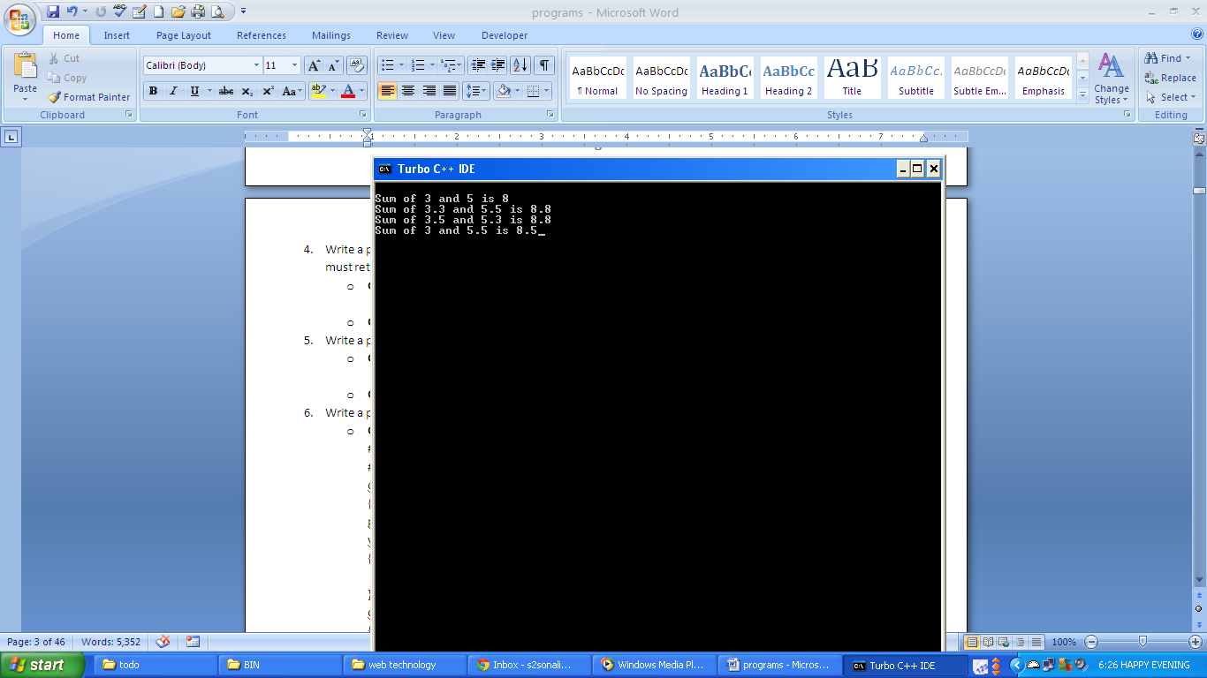

1. **Write a program to implement function overloading with the help of default arguments.**
   * **Code:**

#include<iostream.h>

#include<conio.h>

class func_overload

{ double a,b,sum;

public:

void getdata(int c=2,int d=1)

{ a=c; b=d; }

void getadat(float c, float d)

{ a=c; b=d; }

void getdata(double c,double d=3.3)

{ a=c; b=d; }

void getdata(int c,float d)

{ a=c; b=d; }

void getdata(float c,double d)

{ a=c; b=d; }

void add()

{ sum=a+b; }

void output()

{ cout<<"\nSum of "<<a<<" and "<<b<<" is "<<sum<<"\n"; }};

void main()

{ double a,b;

func_overload ob,ob1,ob2;

cout<<"Enter two numbers to add.\n";

cin>>a>>b;

ob.getdata(a,b); ob.add(); ob.output();

cout<<"\nTwo Default Arguments\nEnter one number\n";

cin>>a;

ob1.getdata(a); ob1.add(); ob1.output();

cout<<"\nOne Default Argument\n";

ob2.getdata(); ob2.add(); ob2.output();

}

* + **Output:**

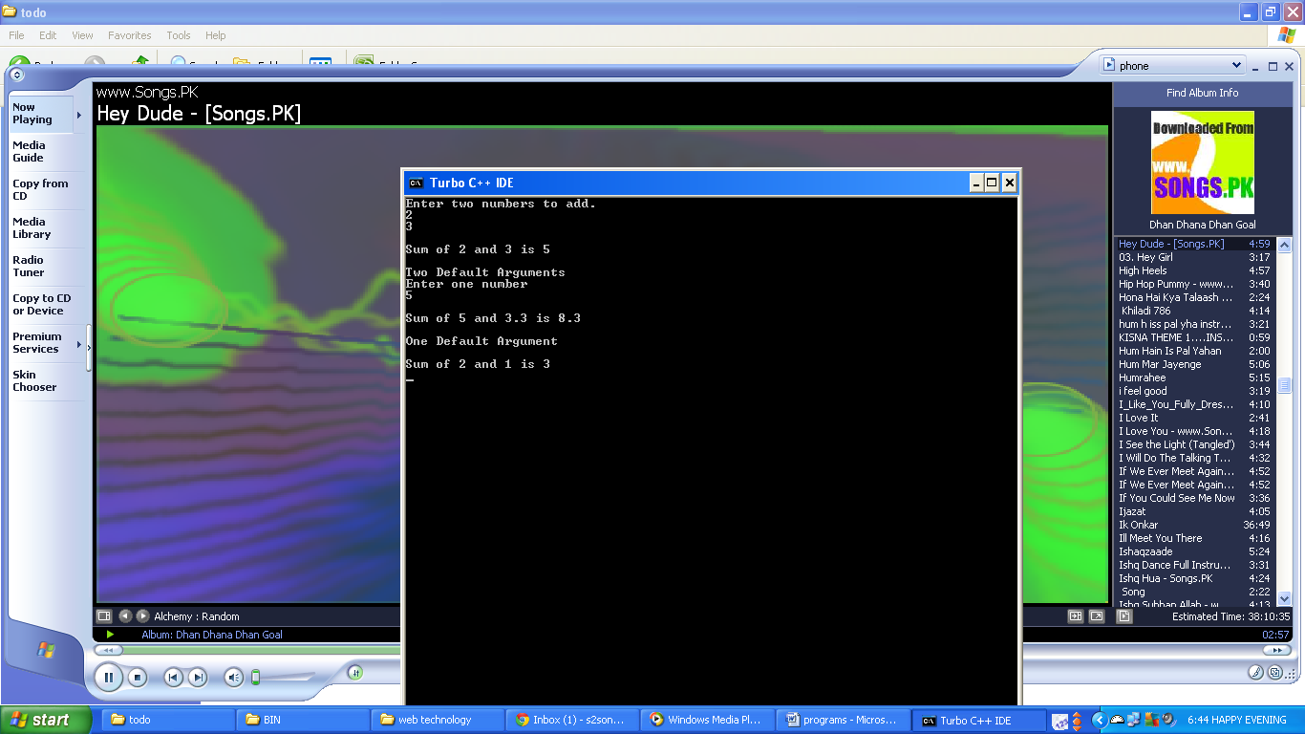

1. **Write a program to calculate sum of two objects by passing objects as arguments.**
   * **Code:**

#include<iostream.h>

#include<conio.h>

class obasarg

{ int a,b;

public:

void getdata(int a, int m)

{ this->a=a; b=m; }

obasarg sum(obasarg o1, obasarg o2)

{ obasarg ob;

ob.a=o1.a+o2.a; ob.b=o1.b+o2.b;

return ob;

}

void disp()

{ cout<<"\n a:"<<a<<"\n b:"<<b; }};

void main()

{ obasarg ob1, ob2, ob3, ob4;

int m,n;

cout<<"\n Enter any two integer for object ob1\n";

cin>>m>>n; ob1.getdata(m,n);

cout<<"\n Enter any two integer for object ob2\n";

cin>>m>>n; ob2.getdata(m,n); ob4=ob3.sum(ob1,ob2);

cout<<"\nFirst object: \n";

ob1.disp();

cout<<"\nSecond object:\n";

ob2.disp();

cout<<"\nSum of two objects:\n";

ob4.disp();

}

* + **Output:**

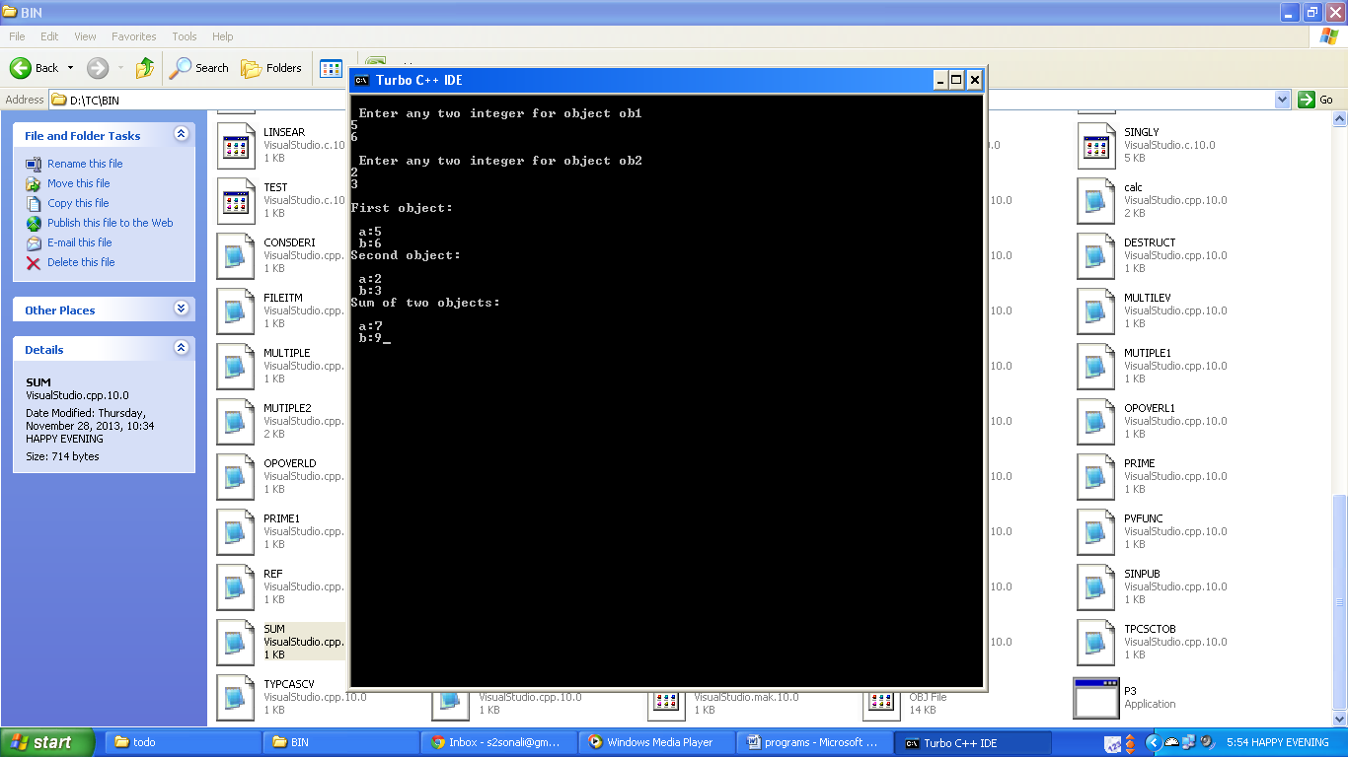

1. **Write a program to display the sum of two objects by passing objects as arguments. Create a class representing time with three instance variables (hours, min, and secs).**
   * **Code:**

#include<iostream.h>

#include<conio.h>

class time

{ int hrs,min,sec;

public:

void getdata(int h,int m,int s)

{ hrs=h; min=m; sec=s; }

time sum(time o1,time o2)

{ time ob;

ob.hrs=o1.hrs+o2.hrs;

ob.min=o1.min+o2.min; ob.sec=o1.sec+o2.sec;

ob.min=ob.min+(ob.sec/60);

ob.sec=ob.sec%60; ob.hrs=ob.hrs+(ob.min/60);

ob.min=ob.min%60; return ob; }

void disp()

{ cout<<"Hours:"<<hrs<<"\n Mins:"<<min<<"\n Secs:"<<sec; }};

void main()

{ int h,m,s;

time ob1,ob2,ob3,ob4;

cout<<"Enter time for object 1\n";

cin>>h>>m>>s; ob1.getdata(h,m,s);

cout<<"Enter time for object 2\n";

cin>>h>>m>>s; ob2.getdata(h,m,s);

ob4=ob3.sum(ob1,ob2);

cout<<"First object:\n"; ob1.disp();

cout<<"Second object:\n"; ob2.disp();

cout<<"Sum of two objects:\n"; ob4.disp();

}

* + **Output:**

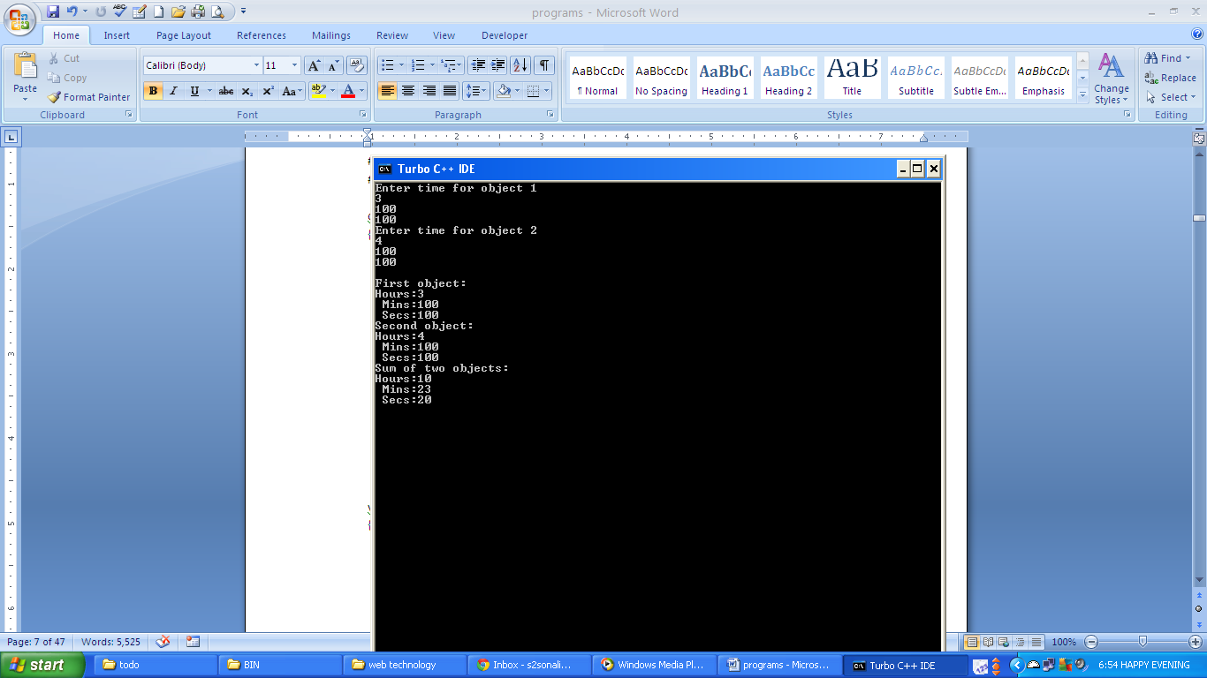

1. **Write a program to make an outside function inline.**
   * **Code:**

#include<iostream.h>

#include<conio.h>

class inline_func

{

public:

inline void disp_inline()

{

cout<<"Inline function defined inside class";

}

void disp_noninline();

};

inline void inline_func::disp_noninline()

{

cout<<"\nInline function defined outside class";

}

void main()

{

clrscr();

inline_func ob;

ob.disp_inline();

ob.disp_noninline();

}

* + **Output:**

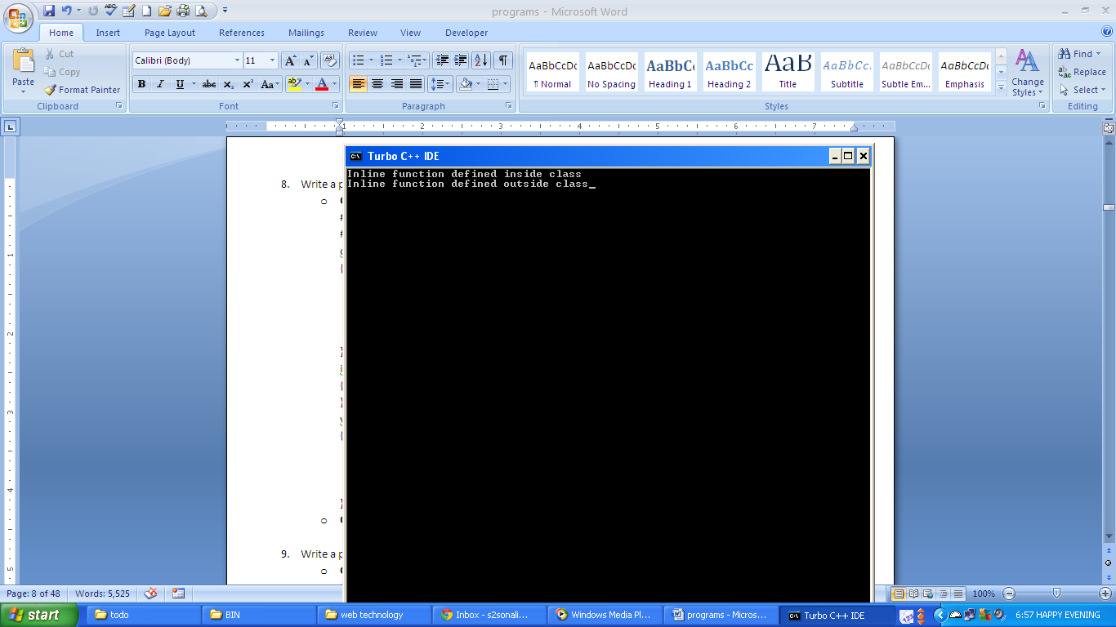

1. **Write a program to sum two numbers by using nesting of member functions.**
   * **Code:**

#include<iostream.h>

#include<conio.h>

class nesting_func

{

int a,b;

public:

void getdata(int m, int n)

{

a=m;

b=n;

}

int sum()

{

int k;

k=a+b;

return k;

}

void disp()

{

cout<<"a: "<<a<<"\nb: "<<b;

int m=sum();

cout<<"\nSum :"<<m;

}

};

void main()

{

clrscr();

nesting_func ob;

ob.getdata(3,4);

ob.disp();

}

* + **Output:**

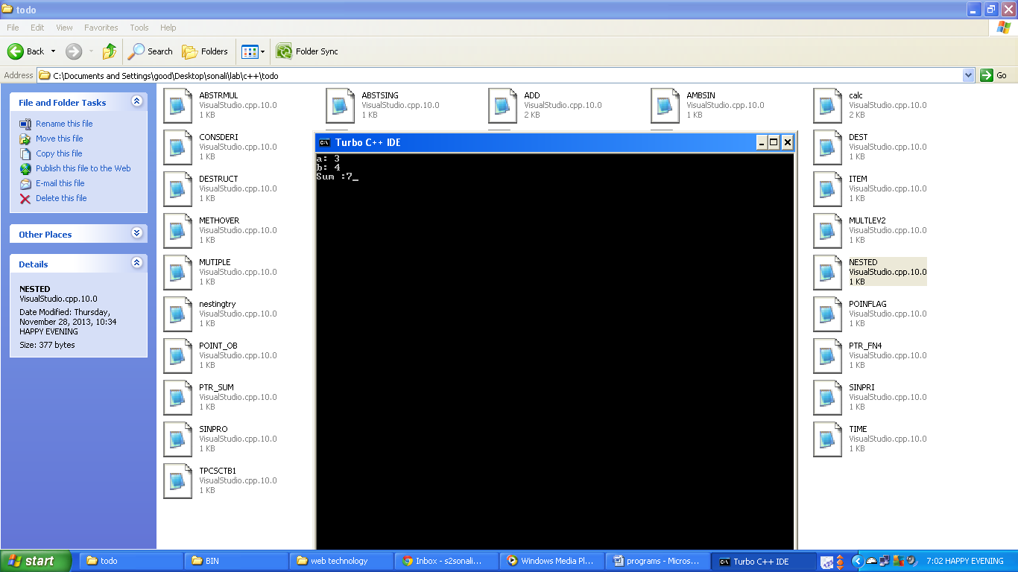

1. **Write a program to call a private function.**
   * **Code:**

#include<iostreame.h>

#include<conio.h>

class pvt

{

void disp()

{

cout<<"Hello";

}

public:

void disp1()

{

disp();

cout<<"\nHi";

}

};

void main()

{

clrscr();

pvt ob;

ob.disp1();

}

* + **Output:**

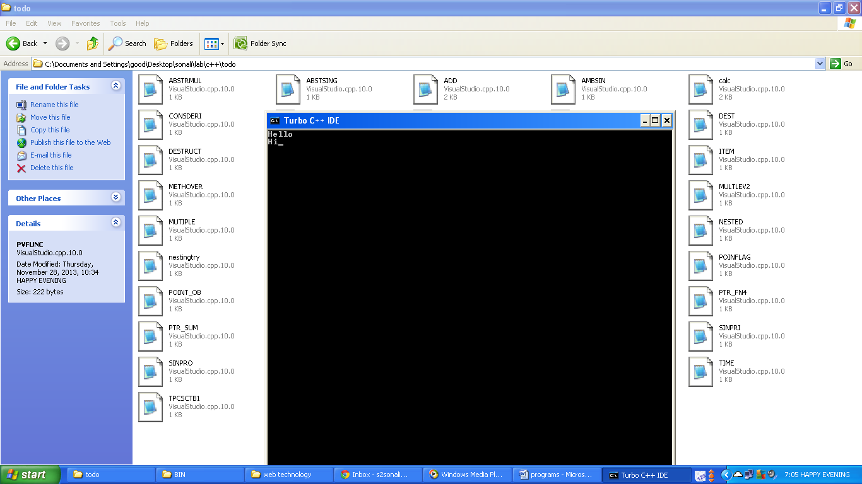

1. **Write a program to show concept of static members.**
   * **Code:**

#include<iostream.h>

#include<conio.h>

class static_var

{

static int a;

public:

void inc()

{

a++;

}

void disp()

{

cout<<"a: "<<a<<"\n";

}

};

int static_var :: a=7;

void main()

{

clrscr();

static_var ob,ob1,ob2;

ob.disp();

ob1.disp();

ob2.disp();

ob.inc();

ob1.inc();

ob2.inc();

ob.disp();

ob1.disp();

ob2.disp();

}

* + **Output:**

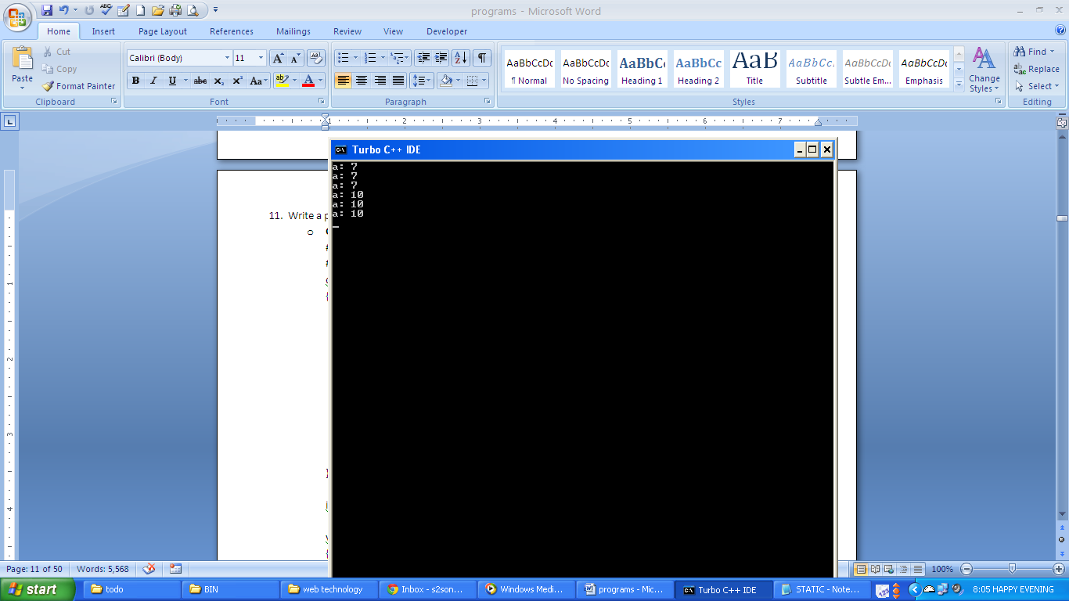

1. **Write a program to create a class which stores roll number and marks of students using array within the class. Calculate average marks of the class assuming there are 10 students.**
   * **Code:**

#include<iostream.h>

class student

{ int marks[10],roll[10];

public:

void getdata()

{ for(int i=0;i<10;i++)

{ cout<<"Enter roll no. and marks of student.";

cin>>roll[i]>>marks[i]; } }

float avg()

{ int sum=0; for(int i=0;i<10;i++)

sum=sum+marks[i];

float avg1=sum/10.0; return avg1; }

void disp()

{ cout<<"\nStudent Details:\n";

for(int i=0;i<10;i++)

cout<<"\nStudent "<<(i+1)<<":\nRoll NO.: "<<roll[i]<<"\tMarks: "<<marks[i];}};

void main()

{ float b; student ob; ob.getdata();

b=ob.avg(); ob.disp(); cout<<"\n\nAverage marks are: "<<b;}

* + **Output:**

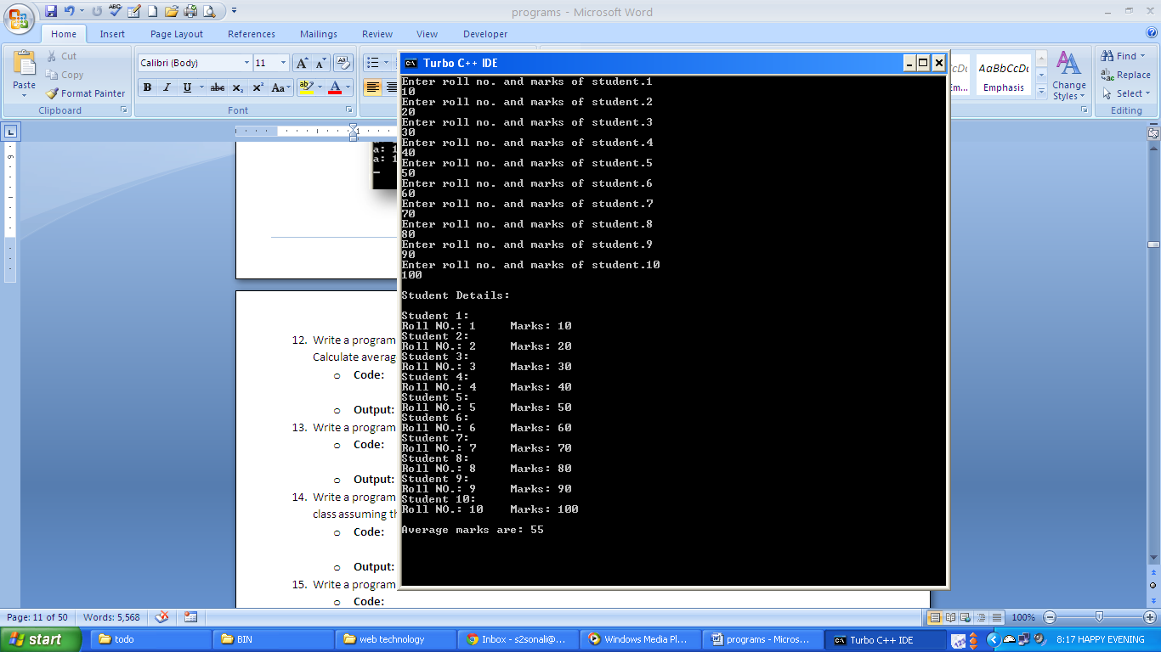

1. **Write a program to show working of static member function.**
   * **Code:**

#include<iostream.h>

#include<conio.h>

class static_func

{

static int a;

public:

void getdata()

{

a++;

}

static void staticf()

{

cout<<"\nStatic Function.";

}

static void disp()

{

cout<<"a: "<<a;

staticf();

}

};

int static_func::a;

void main()

{

clrscr();

static_func ob,ob1,ob2;

ob.getdata();

ob1.getdata();

ob2.getdata();

static_func::disp();

}

* + **Output:**

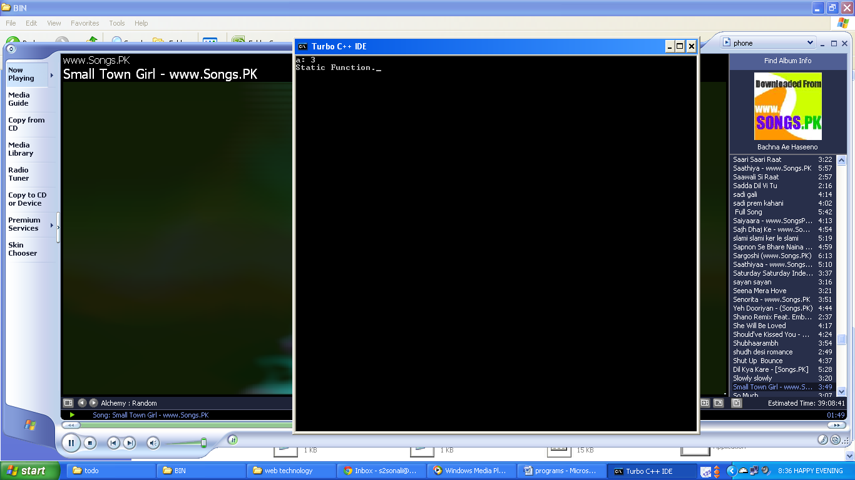

1. **Write a program to create a class to store roll number and marks of the students. Calculate average marks of the class assuming there are 10 students. Use array of objects.**
   * **Code:**

#include<iostream.h>

class student

{ int rollno, marks; static int sum; public:

void getdata(int m,int n)

{ rollno=m; marks=n; }

int sum1()

{ sum=sum+marks; return sum; }

void disp()

{ cout<<"\n Roll no.: "<<rollno<<"\tMarks: "<<marks; }};

int student::sum; void main()

{ int i,r,m; student ob[10];

for(i=0;i<10;i++)

{ cout<<"Enter roll no. and marks for student "<<(i+1)<<":";

cin>>r>>m; ob[i].getdata(r,m); }

for(i=0;i<10;i++)

{ cout<<"\nStudent "<<(i+1)<<" details:"; ob[i].disp(); }

int sum_marks=0; for(i=0;i<10;i++)

sum_marks=ob[i].sum1();

float avg=sum_marks/10.0; cout<<"\nAverage: "<<avg; }

* + **Output:**

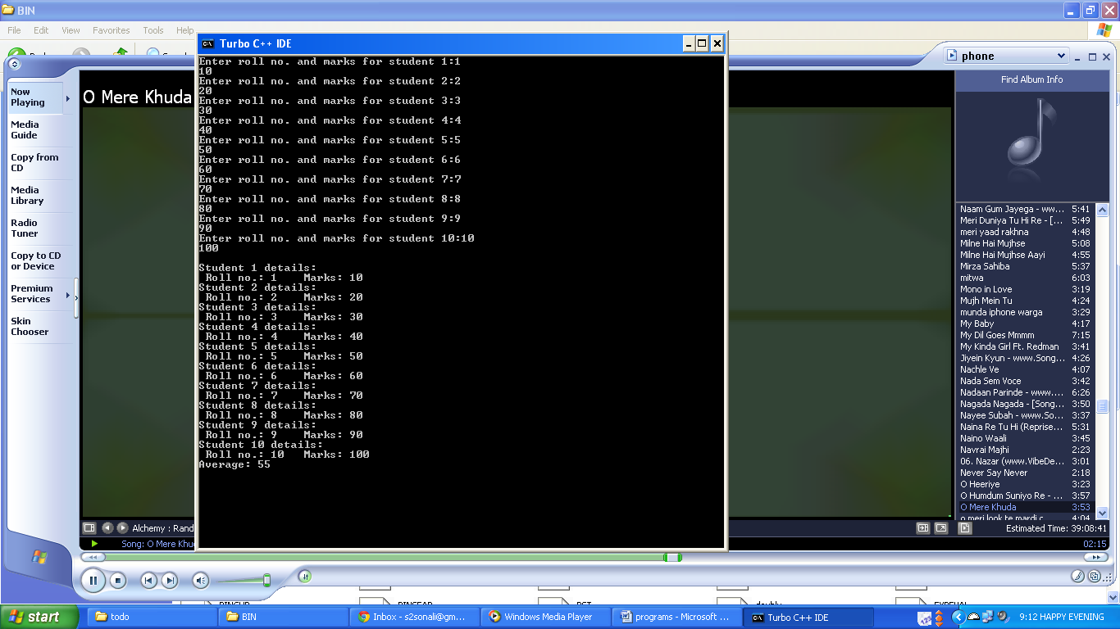

1. **Write a program to show working of destructor.**
   * **Code:**

#include<iostream.h>

#include<conio.h>

class dest

{ public:

dest()

{

cout<<"\ncreated";

}

~dest()

{

cout<<"\ndestroyed";

}};

void main()

{ dest ob,ob1,ob2;

{

dest o1;

cout<<"\nhello";

}

dest ob3,ob4;

cout<<"\nblock";

{

dest o2,o3;

cout<<"\nanother block";

}

dest ob5,ob6;

}

* + **Output:**

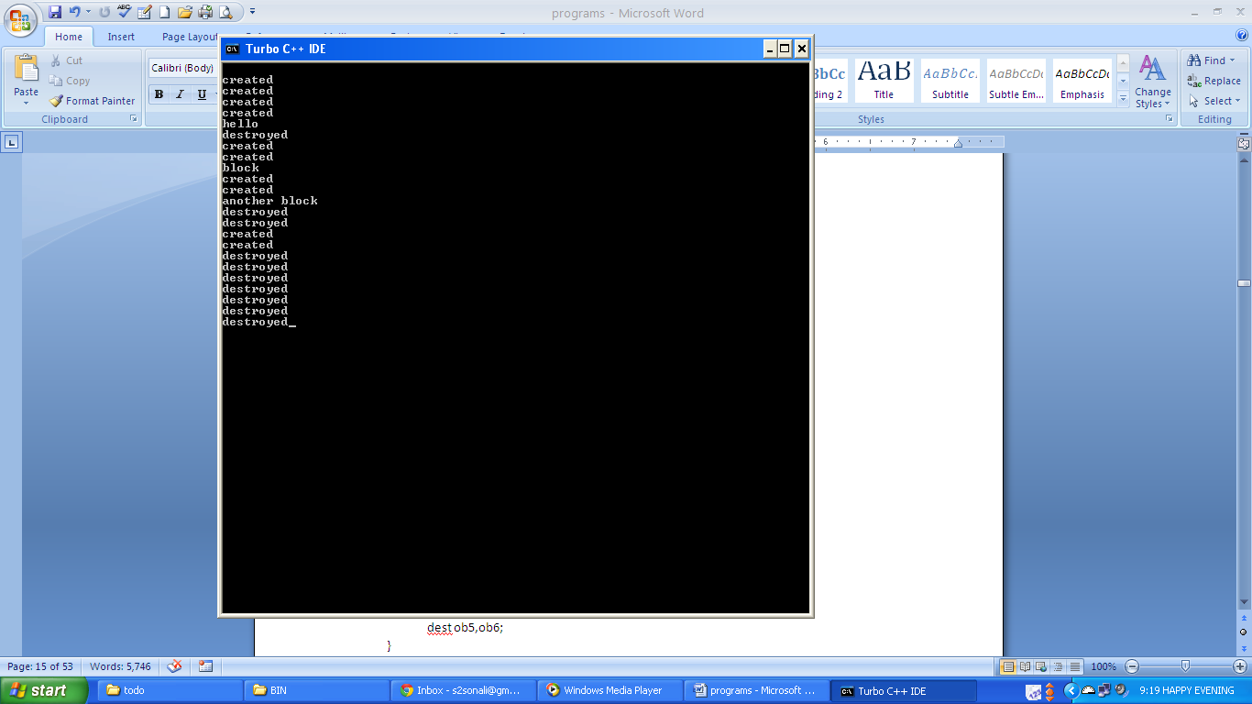

1. **Write a program to create a class to store the item and its price. Create a member function to calculate the number of items being used in the program. Also clean up the storage occupied by the objects created in the program.**
   * **Code:**

#include<iostream.h>

#include<conio.h>

class item

{ static int a;

int code,price;

public:

item()

{ cout<<"Enter item code.\n";

cin>>code;

cout<<"\nEnter item price.\n";

cin>>price;

a++;

cout<<"\nItem Entered.\n";

}

void disp_item()

{ cout<<"\nNumber of items used "<<a;}

~item()

{ cout<<"\nMemory cleaned up."; }};

int item::a;

void main()

{ clrscr();

item ob,ob1;

ob.disp_item();

}

* + **Output:**

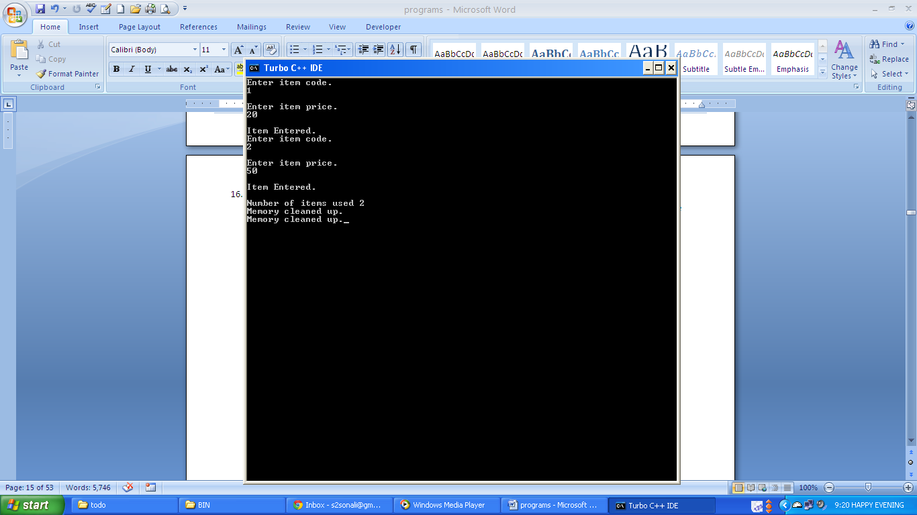

1. **Write a program to create a class to input and display marks in different subjects of a student. Create a child class to calculate the percentage of a student. Create another child class to display the percentage of the student.**
   * **Code:**

#include<iostream.h>

class student

{ int marks[5];

public:

void get_marks();void disp_marks();int sum1();

};

void student::get_marks()

{ for(int i=1;i<=5;i++)

{ cout<<"\nenter marks of subject "<<i<<" : ";cin>>marks[i];}}

void student:: disp_marks()

{ for(int i=1;i<=5;i++)

cout<<"\nmarks of subject "<<i<<" :"<<marks[i];}

int student::sum1()

{ int sum=0;

for(int i=1;i<=5;i++)

sum=sum+marks[i];

cout<<"\nSum of marks is:"<<sum;return sum;}

class percentage : public student

{ public:

float per()

{ get_marks();disp_marks();

int s=sum1();float perc=((s/500.0)*100);return perc;}};

class disp : public percentage

{ public:

void disp_perc()

{ float p=per();cout<<"\nPercentage is:" <<p;}};

void main()

{ disp ob1;ob1.disp_perc(); }

* + **Output:**

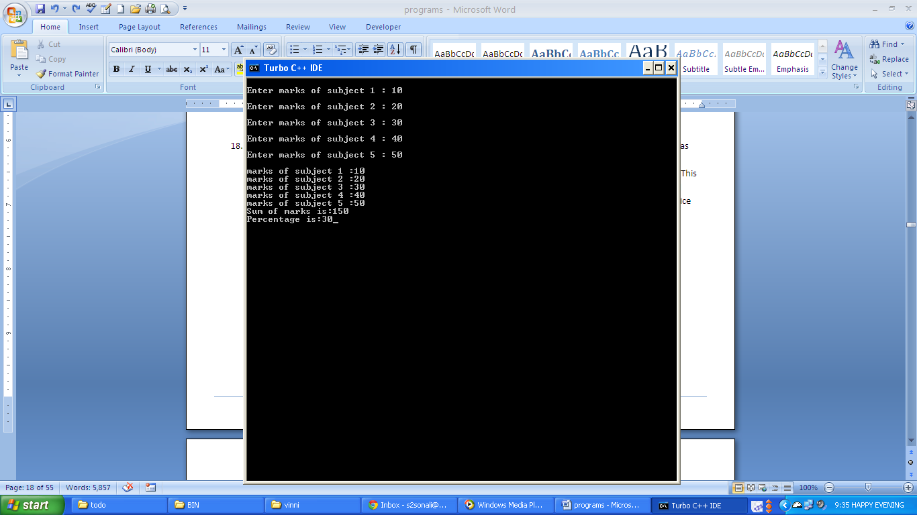

1. **Write a program to create a class item to get the item code and item price from the user. Declare item code as protected member and item price as a private member. Input function to get these values must be private. Display function must be protected. Derive a quantity class from class item in a private mode of inheritance. This class will deal with total number of items required from the user. This must be private. Function to input and display the number of items must be protected. Derive another class from quantity class to calculate total price incurred by the user. This inheritance must be protected.**
   * **Code:**

#include<iostream.h>

class item

{ int price;

void input(int a, int b)

{ code=a; price=b; }

protected: int code; void disp()

{ cout<<"\n\nItem Code: "<<code<<"\nPrice: "<<price; }

public: void data()

{ int a,b;

cout<<"Enter item code.\n"; cin>>a;

cout<<"\nEnter item price.\n"; cin>>b;

input(a,b); disp(); }

int pr()

{ int pr1=price; return pr1; }};

class quantity:item

{ int n;

protected: void get()

{ cout<<"\n\nEnter number of item.\n"; cin>>n;

cout<<"\nNumber of items: "<<n; }

public: int total; void calc()

{ int pr1=pr(); total=n*pr1; }

void output()

{ data(); get(); calc(); }};

class deri:protected quantity

{ public: void disp1()

{ output(); cout<<"\nTotal Price: "<<total; }};

void main(){ deri ob; ob.disp1();}

* + **Output:**

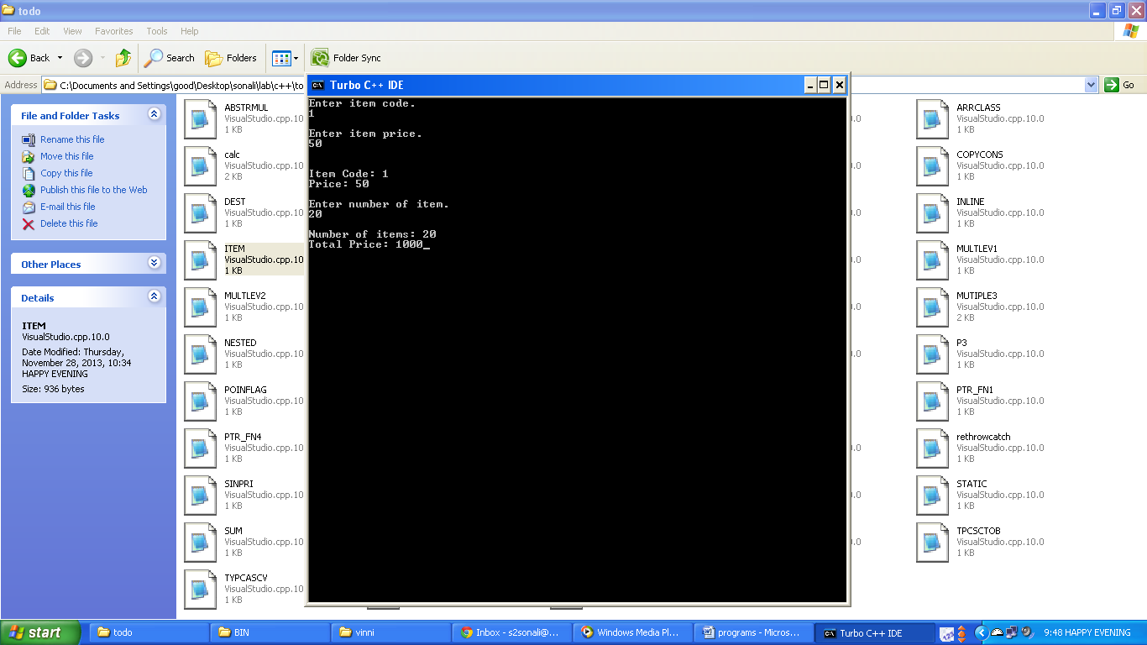

1. **Write a program to implement single level inheritance in: (Data members should be private)**
2. **public mode**
   * **Code:**

#include<iostream.h>

class item

{ int code;

float price;

int no_item;

public:

void input(int c,float p,int n)

{ code=c;price=p;no_item=n;}

void display()

{ cout<<" \nItem code:"<<code;

cout<<"\nPrice of an item:"<<price;

Cout<<"\nNumber of items:"<<no_item; }

float rt_p()

{ float p=price;return p;}

int rt_n()

{ int n=no_item;return n;}};

class total:public item

{ float total_p;

public:

void call()

{ input(1,20.0f,50);

display();}

void calc()

{ total_p=(rt_p() * rt_n());}

void disp_total()

{ cout<<"\nTotal price:"<<total_p;}};

void main()

{ total ob;

ob.call();

ob.calc();

ob.disp_total();

}

* + **Output:**

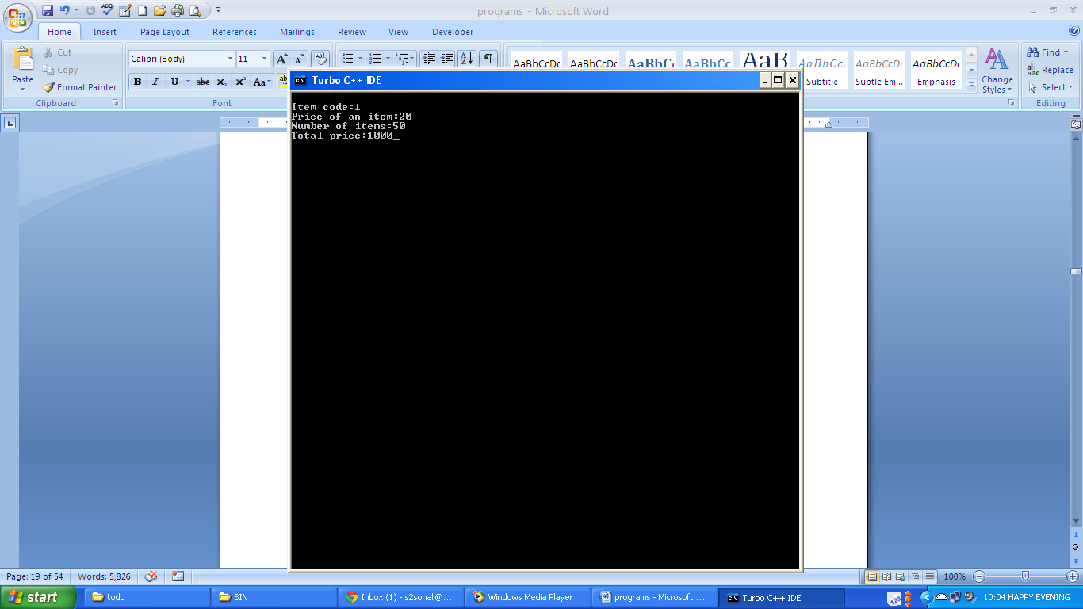

1. **protected mode**
   * **Code:**

#include<iostream.h>

#include<conio.h>

class item

{ int code;

float price;

int no_item;

public:

void input(int c,float p,int n)

{ code=c;

price=p;

no_item=n;}

void display()

{ cout<<"\nItem code:"<<code;

cout<<"\nPrice of an item:"<<price;

cout<<"\nNumber of items:"<<no_item;}

float rt_p()

{ float p=price;return p;}

int rt_n()

{ int n=no_item;return n;}};

class total:protected item

{ float total_p;

public:

void call()

{ input(1,20.0f,50);

display();

}

void calc()

{ total_p=(rt_p() * rt_n());}

void disp_total()

{ cout<<"\nTotal price:"<<total_p;}};

void main()

{ total ob;

ob.call();

ob.calc();

ob.disp_total();

}

* + **Output:**

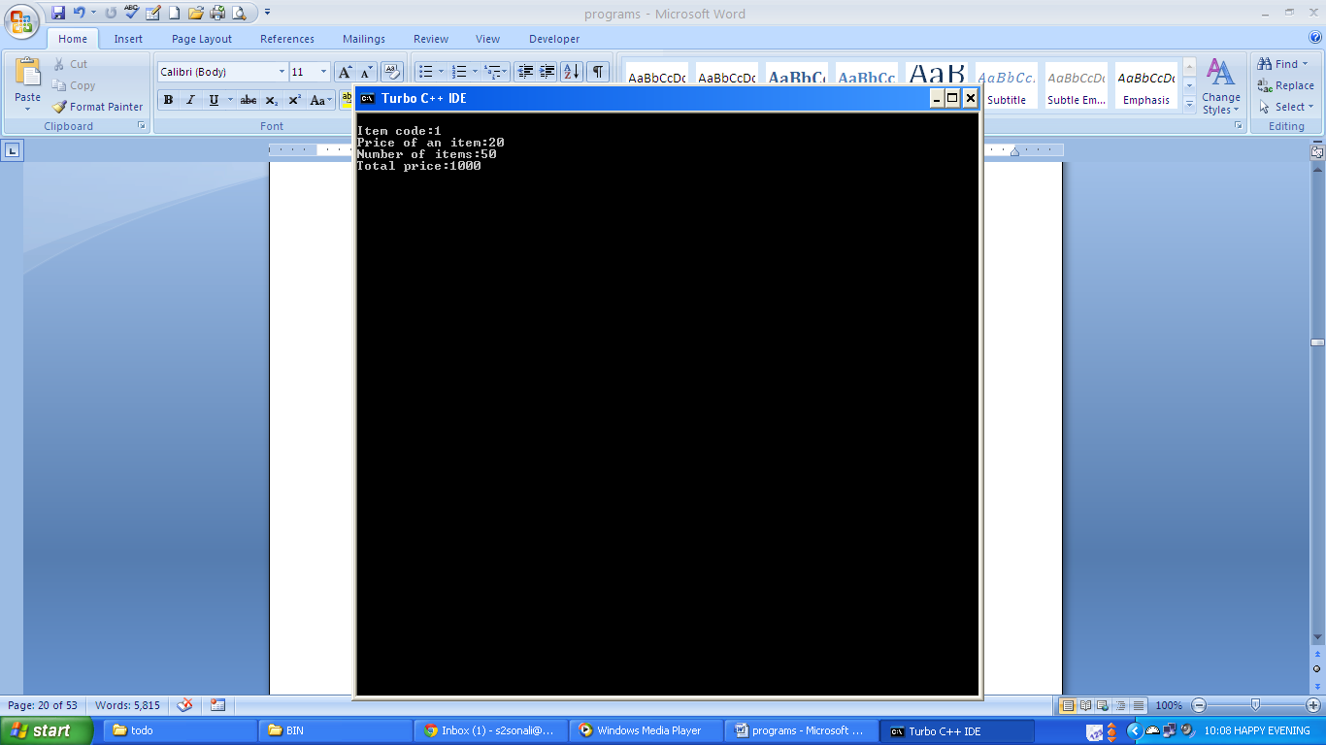

1. **private mode**
   * **Code:**

#include<iostream.h>

class item

{ int code;

float price;

int no_item;

public:

void input(int c,float p,int n)

{ code=c;price=p;

no_item=n;

}

void display()

{ cout<<"\nItem code:"<<code;

cout<<"\nPrice of an item:"<<price;

cout<<"\nNumber of items:"<<no_item;

}

float rt_p()

{ float p=price;return p;}

int rt_n()

{ int n=no_item;return n;}};

class total:private item

{ float total_p;

public:

void call()

{ input(1,20.0f,50);

display();}

void calc()

{ total_p=(rt_p() * rt_n());}

void disp_total()

{ cout<<"\nTotal price:"<<total_p;}};

void main()

{ total ob;

ob.call();

ob.calc();

ob.disp_total();

}

* + **Output:**

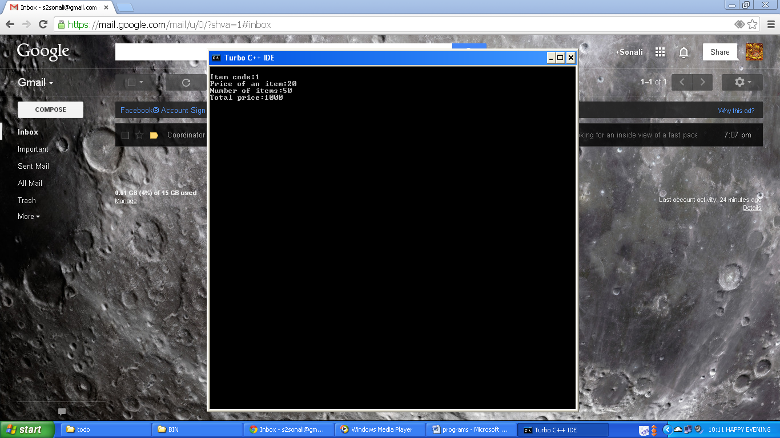

1. **Write a program to implement multilevel inheritance and use member functions to initialize instance variables: (Data Members must be private in all classes)**
2. **first level public, second level private**
   * **Code:**

#include<iostream.h>

class item

{ int code, price;

public:

void input()

{ cout<<"Enter item code.\n"; cin>>code;

cout<<"\nEnter item Price.\n"; cin>>price; }

void disp()

{ cout<<"Item Code: "<<code<<"\nItem Price: "<<price; }

int pr()

{ return price; }};

class quantity:public item

{ int n;

public:

void get()

{ cout<<"\nEnter number of item.\n"; cin>>n; }

void get_disp()

{ cout<<"\nNumber of Items: "<<n; }

int calc()

{ int total;

int price=pr(); total=n*price; return total; }};

class derive:quantity

{ int res;

public:

void disp_res()

{ res=calc(); cout<<"\nTotal Price: "<<res; }

void all()

{ input(); disp();

get(); get_disp(); }};

void main()

{ derive ob; ob.all(); ob.disp_res();}

* + **Output:**

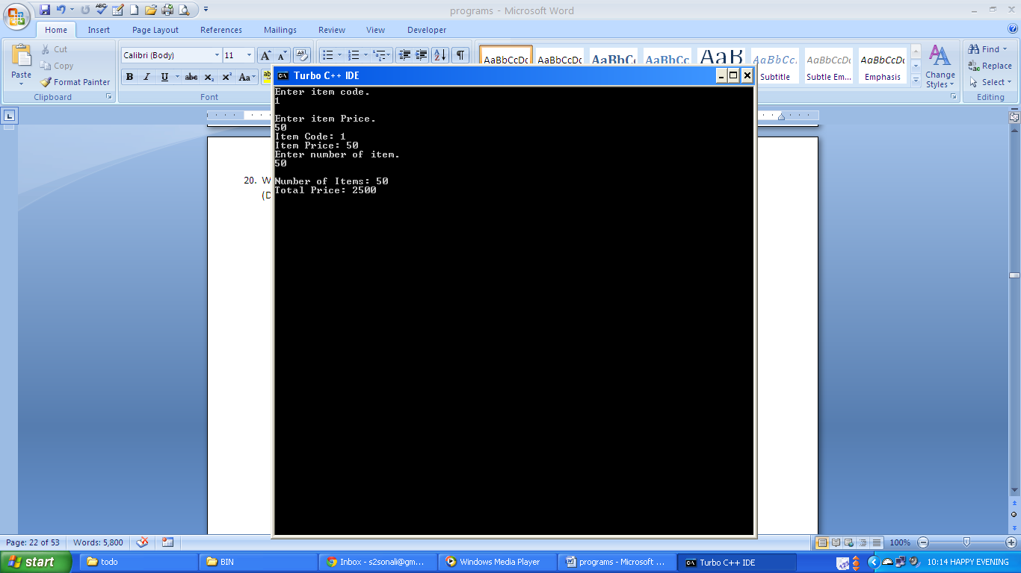

1. **first level public, second level protected**
   * **Code:**

#include<iostream.h>

class item

{ int code, price;

public:

void input()

{ cout<<"Enter item code.\n"; cin>>code;

cout<<"\nEnter item Price.\n"; cin>>price; }

void disp()

{ cout<<"Item Code: "<<code<<"\nItem Price: "<<price; }

int pr()

{ return price;}};

class quantity:public item

{ int n;

public:

void get()

{ cout<<"\nEnter number of item.\n"; cin>>n; }

void get_disp()

{ cout<<"\nNumber of Items: "<<n; }

int calc()

{ int total;

int price=pr(); total=n*price; return total; }};

class derive:protected quantity

{ int res;

public:

void disp_res()

{ res=calc();cout<<"\nTotal Price: "<<res; }

void all()

{ input(); disp();

get(); get_disp(); }};

void main()

{ derive ob;ob.all();ob.disp_res();

}

* + **Output:**

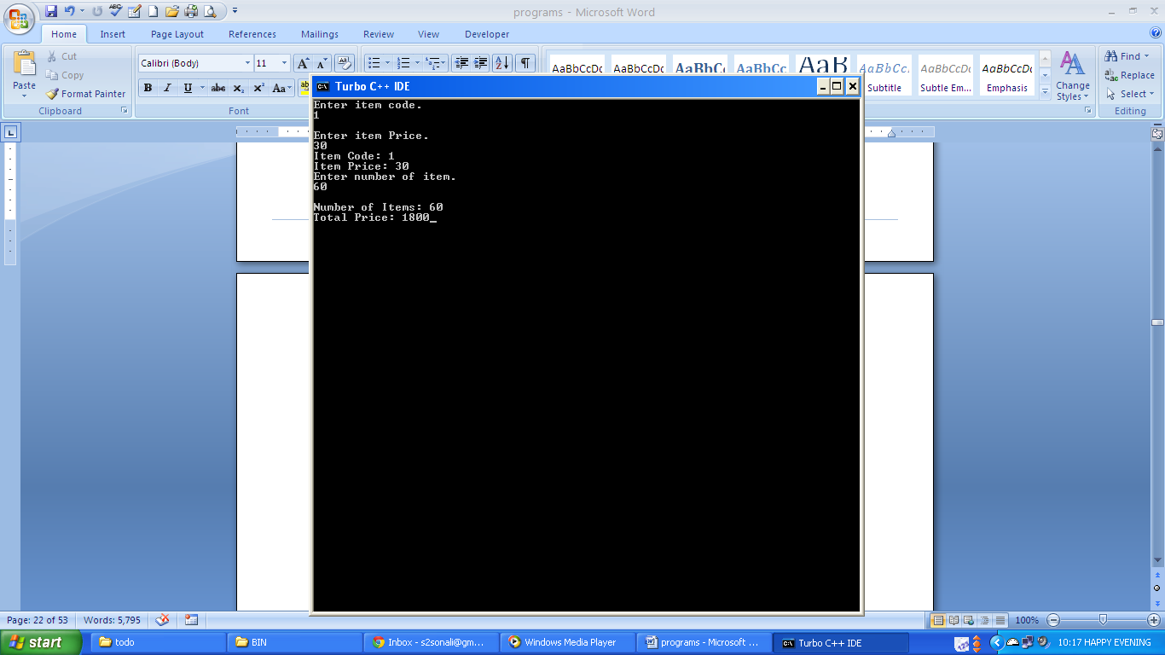

1. **first level private, second level protected**
   * **Code:**

#include<iostream.h>

class item

{ int code, price;

public:

void input()

{ cout<<"Enter item code.\n"; cin>>code;

cout<<"\nEnter item Price.\n"; cin>>price; }

void disp()

{ cout<<"Item Code: "<<code<<"\nItem Price: "<<price; }

int pr()

{ return price; }};

class quantity:item

{ int n;

public:

void get()

{ cout<<"\nEnter number of item.\n"; cin>>n; }

void get_disp()

{ cout<<"\nNumber of Items: "<<n; }

int calc()

{ int total;

int price=pr(); total=n*price; return total; }

void all()

{ input(); disp(); }};

class derive:protected quantity

{ int res;

public:

void disp_res()

{ res=calc(); cout<<"\nTotal Price: "<<res; }

void all1()

{ all(); get(); get_disp(); }};

void main()

{ derive ob;ob.all1();ob.disp_res();

}

* + **Output:**

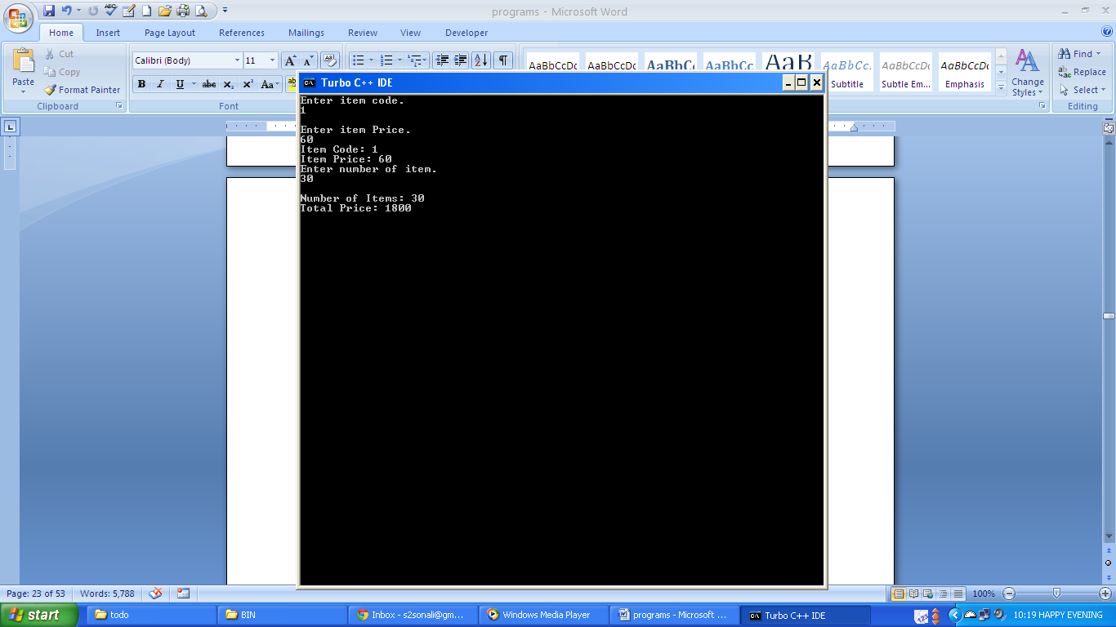

1. **Write a program for ambiguity resolution in single level inheritance and use member functions to initialize instance variables.**
   * + **Code:**

#include<iostream.h>

#include<conio.h>

class base

{

public:

void disp()

{

cout<<"\nBase Class";

}

};

class derived:public base

{

public:

void disp()

{

cout<<"\n Derived class";

}

};

void main()

{

clrscr();

derived ob;

ob.disp();

ob.base::disp();

ob.derived::disp();

}

* + - **Output:**

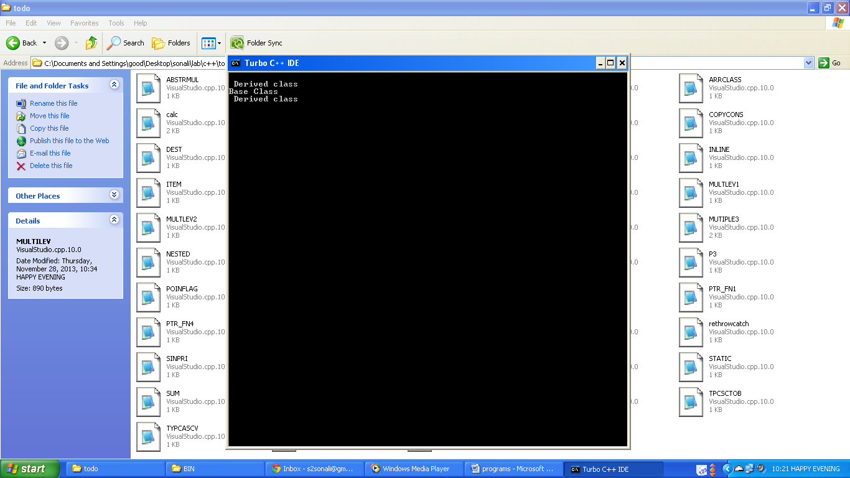

1. **Write a program to implement multiple inheritances and use member functions to initialize instance variables:**
2. **public, public**
   * **Code:**

#include<iostream.h>

#include<conio.h>

#include<string.h>

class student

{ char *name;

int roll;

public:

void get(int r, char *n)

{ roll=r; strcpy(name,n); }

void disp()

{ cout<<"Roll No: "<<roll<<"\nName: "<<name; }};

class std_marks

{ protected:

int m1,m2,m3;

public:

void marks(int a,int b,int c)

{ m1=a; m2=b; m3=c; }

void marks1()

{ cout<<"\nMarks1: "<<m1<<"\nMarks2: "<<m2<<"\nMarks3: "<<m3; }};

class std_perc:public student,public std_marks

{ public:

void calc_per()

{ float s=(m1+m2+m3)/3.0;

cout<<"\nPercentage: "<<s<<"\n"; }};

void main()

{ std_perc ob;

int r;

char *n;

cout<<"Enter roll no.\n"; cin>>r;

cout<<"\nEnter Name.\n"; cin>>n;

ob.get(r,n); ob.marks(90,90,90);

ob.disp(); ob.marks1(); ob.calc_per();}

* + **Output:**

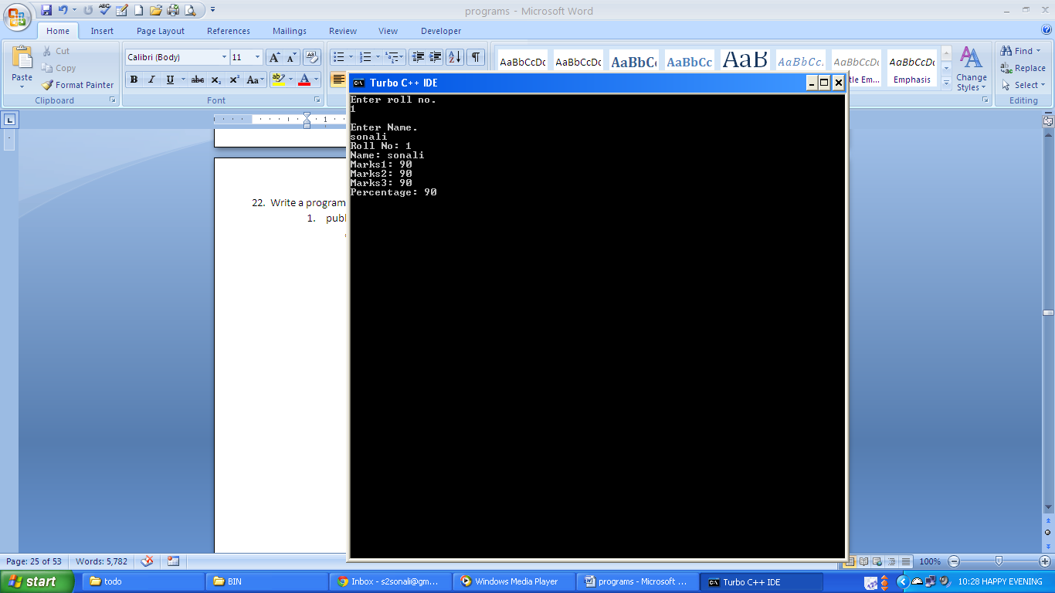

1. **public, private**
   * **Code:**

#include<iostream.h>

#include<conio.h>

#include<string.h>

class student

{ char *name;

int roll;

public:

void get(int r, char *n)

{ roll=r; strcpy(name,n); }

void disp()

{ cout<<"Roll No: "<<roll<<"\nName: "<<name; }};

class std_marks

{ protected:

int m1,m2,m3;

public:

void marks(int a,int b,int c)

{ m1=a; m2=b; m3=c; }

void marks1()

{ cout<<"\nMarks1: "<<m1<<"\nMarks2: "<<m2<<"\nMarks3: "<<m3; }};

class std_perc:public student,std_marks

{ public:

void calc_per()

{ float s=(m1+m2+m3)/3.0; cout<<"\nPercentage: "<<s<<"\n"; }

void get_marks(int a,int b,int c)

{ marks(a,b,c); }

void disp_marks()

{ marks1(); }};

void main()

{ std_perc ob; int r; char *n;

cout<<"Enter roll no.\n"; cin>>r;

cout<<"\nEnter Name.\n"; cin>>n;

ob.get(r,n); ob.get_marks(90,90,90);

ob.disp(); ob.disp_marks(); ob.calc_per(); }

* + **Output:**



1. **protected, private**
   * **Code:**

#include<iostream.h>

#include<string.h>

class student

{ char *name; int roll;

public: void get(int r, char *n)

{ roll=r; strcpy(name,n); }

void disp()

{ cout<<"Roll No: "<<roll<<"\nName: "<<name; }};

class std_marks

{ protected: int m1,m2,m3;

public: void marks(int a,int b,int c)

{ m1=a; m2=b; m3=c; }

void marks1()

{ cout<<"\nMarks1: "<<m1<<"\nMarks2: "<<m2<<"\nMarks3: "<<m3; }};

class std_perc:protected student,std_marks

{ public:

void calc_per()

{ float s=(m1+m2+m3)/3.0;cout<<"\nPercentage: "<<s<<"\n"; }

void input(int a,char *b)

{ get(a,b); }

void input_disp()

{ disp(); }

void get_marks(int a,int b,int c)

{ marks(a,b,c); }

void disp_marks()

{ marks1(); }};

void main()

{ std_perc ob; int r; char *n;

cout<<"Enter roll no.\n"; cin>>r;

cout<<"\nEnter Name.\n"; cin>>n;

ob.input(r,n); ob.get_marks(90,90,90);

ob.input_disp(); ob.disp_marks();

ob.calc_per(); }

* + **Output:**



1. **private, protected**
   * **Code:**

#include<iostream.h>

#include<string.h>

class student

{ char *name; int roll;

public: void get(int r, char *n)

{ roll=r; strcpy(name,n); }

void disp()

{ cout<<"Roll No: "<<roll<<"\nName: "<<name; }};

class std_marks

{ protected: int m1,m2,m3;

public: void marks(int a,int b,int c)

{ m1=a; m2=b; m3=c; }

void marks1()

{ cout<<"\nMarks1: "<<m1<<"\nMarks2: "<<m2<<"\nMarks3: "<<m3; }};

class std_perc:student,protected std_marks

{ public: void calc_per()

{ float s=(m1+m2+m3)/3.0;cout<<"\nPercentage: "<<s<<"\n"; }

void input(int a,char *b)

{ get(a,b); }

void input_disp()

{ disp(); }

void get_marks(int a,int b,int c)

{ marks(a,b,c); }

void disp_marks()

{ marks1(); }};

void main()

{ std_perc ob;

int r; char *n;

cout<<"Enter roll no.\n"; cin>>r;

cout<<"\nEnter Name.\n"; cin>>n;

ob.input(r,n); ob.get_marks(90,90,90);

ob.input_disp(); ob.disp_marks();

ob.calc_per();}

* + **Output:**



1. **Use constructor to initialize instance variables for Q 19, Q20 and Q 22.**
   * + **Q19.**
       1. **public mode**
          - **Code:**

#include<iostream.h>

#include<conio.h>

class item

{ int code, no_item;

float price;

public:

item(int c,float p,int n)

{code=c;price=p;no_item=n;}

void display()

{ cout<<"\nItem code:"<<code<<"\nPrice of an item:"<<price;

cout<<"\nNumber of items:"<<no_item;}

float rt_p()

{ float p=price;return p;}

int rt_n()

{ int n=no_item;return n;}};

class total:public item

{ float total_p;

public:

total(int c,float p,int n):item(c,p,n){}

void call()

{display();}

void calc()

{total_p=(rt_p() * rt_n());}

void disp_total()

{cout<<"\nTotal price:"<<total_p;}};

void main()

{ total ob(1,20.0f,50);

ob.call();

ob.calc();

ob.disp_total();

* + - * + **Output:**

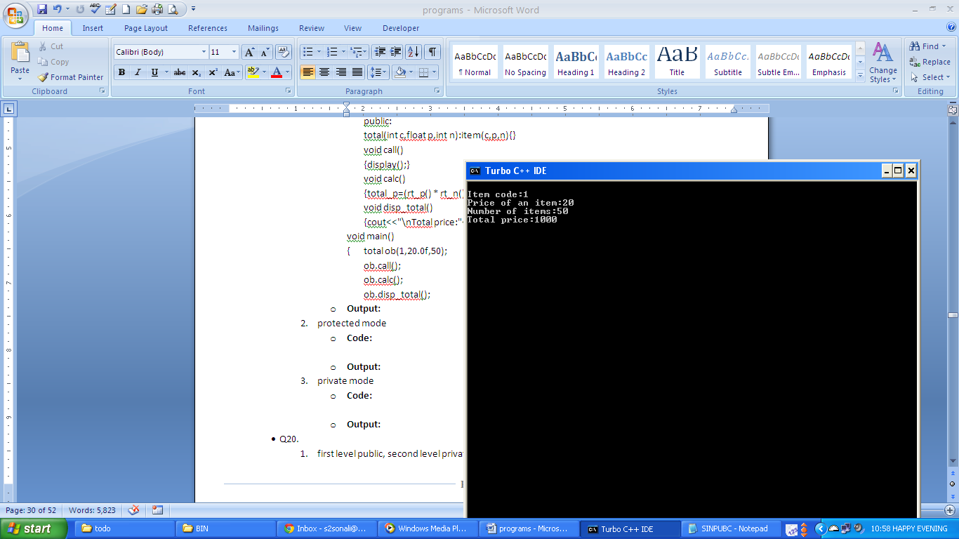

* + - 1. **protected mode**
         * **Code:**

#include<iostream.h>

#include<conio.h>

class item

{ int code,no_item;

float price;

public:

item(int c,float p,int n)

{ code=c;price=p;no_item=n;}

void display()

{ cout<<"\nItem code:"<<code<<"\nPrice of an item:"<<price;

cout<<"\nNumber of items:"<<no_item;}

float rt_p()

{ float p=price;return p;}

int rt_n()

{ int n=no_item;return n;}};

class total:protected item

{ float total_p;

public:

total(int c,float p,int n):item(c,p,n){}

void call()

{ display();}

void calc()

{ total_p=(rt_p() * rt_n());}

void disp_total()

{ cout<<"\nTotal price:"<<total_p;}};

void main()

{ total ob(1,20.0f,50);

ob.call();ob.calc();ob.disp_total();}

* + - * + **Output:**

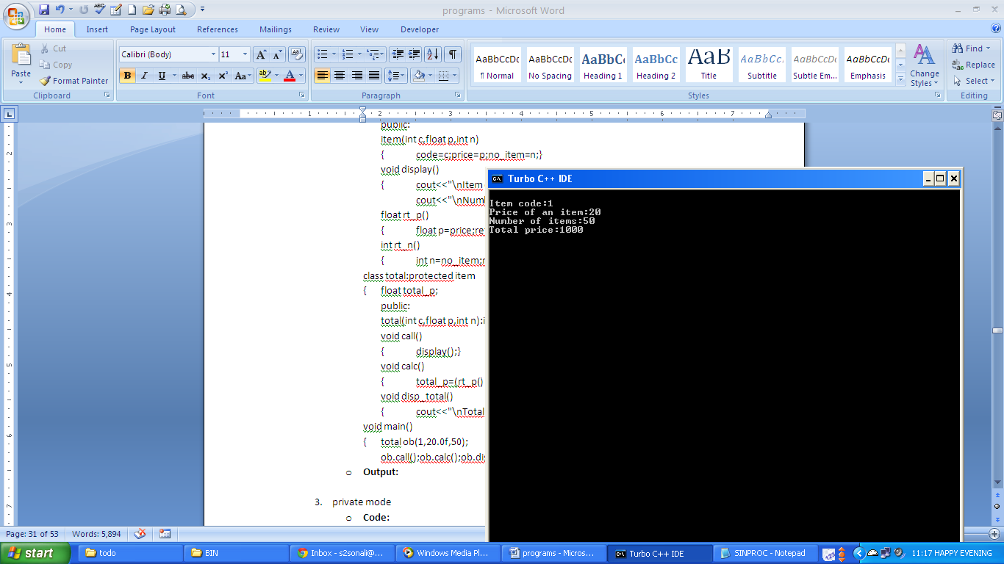

* + - 1. **private mode**
         * **Code:**

#include<iostream.h>

#include<conio.h>

class item

{ int code, no_item;

float price;

public:

item(int c,float p,int n)

{ code=c;

price=p;

no_item=n;

}

void display()

{ cout<<"\nItem code:"<<code<<"\nPrice of an item:"<<price;

cout<<"\nNumber of items:"<<no_item;

}

float rt_p()

{ float p=price;return p;}

int rt_n()

{ int n=no_item;return n;}};

class total:private item

{ float total_p;

public:

total(int c,float p,int n):item(c,p,n){}

void call()

{ display();}

void calc()

{ total_p=(rt_p() * rt_n());}

void disp_total()

{ cout<<"\nTotal price:"<<total_p;}};

void main()

{ total ob(1,20.0f,50);

ob.call();

ob.calc();

ob.disp_total();

}

* + - * + **Output:**

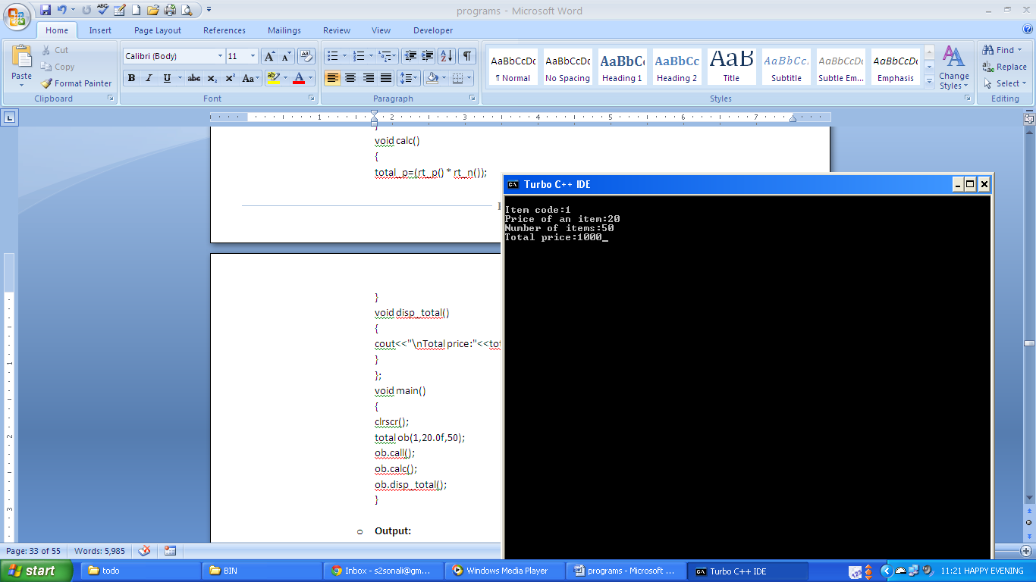

* + - **Q20.**
      1. **first level public, second level private**
         * **Code:**

#include<iostream.h>

#include<conio.h>

class item

{ int code, price;

public:

item(int c,float p):code(c),price(p){}

void disp()

{ cout<<"Item Code: "<<code<<"\nItem Price: "<<price; }

int pr()

{ return price; }};

class quantity:public item

{ int n1;

public:

quantity(int c,float p,int n):item(c,p),n(n1){}

void get_disp()

{ cout<<"\nNumber of Items: "<<n1; }

int calc()

{ int total;

int price=pr(); total=n1*price;

return total; }};

class derive:quantity

{ int res;

public:

derive(int c,float p,int n):quantity(c,p,n){}

void disp_res()

{ res=calc(); cout<<"\nTotal Price: "<<res; }

void all()

{ disp(); get_disp(); }};

void main()

{ derive ob(1,20.0f,50);

ob.all(); ob.disp_res();}

* + - * + **Output:**



* + - 1. **first level public, second level protected**
         * **Code:**

#include<iostream.h>

class item

{ int code, price;

public:

item(int c,float p):code(c),price(p){}

void disp()

{ cout<<"Item Code: "<<code<<"\nItem Price: "<<price; }

int pr()

{ return price; }};

class quantity:public item

{ int n;

public:

quantity(int c,float p,int n1):item(c,p),n(n1){}

void get_disp()

{ cout<<"\nNumber of Items: "<<n; }

int calc()

{ int total;

int price=pr(); total=n*price;

return total;

}};

class derive:protected quantity

{ int res;

public:

derive(int c,float p,int n):quantity(c,p,n){}

void disp_res()

{ res=calc();cout<<"\nTotal Price: "<<res; }

void all()

{ disp(); get_disp(); }};

void main()

{ derive ob(1,20.0f,50);

ob.all(); ob.disp_res();}

* + - * + **Output:**



* + - 1. **first level private, second level protected**
         * **Code:**

#include<iostream.h>

#include<conio.h>

class item

{ int code, price;

public:

item(int c, float p):code(c),price(p){}

void disp()

{ cout<<"Item Code: "<<code<<"\nItem Price: "<<price; }

int pr()

{ return price; }};

class quantity:item

{ int n;

public:

quantity(int c,float p,int n1):item(c,p),n(n1){}

void get_disp()

{ cout<<"\nNumber of Items: "<<n; }

int calc()

{ int total;

int price=pr(); total=n*price;

return total; }

void all()

{ disp(); }};

class derive:protected quantity

{ int res;

public:

derive(int c,float p,int n):quantity(c,p,n){}

void disp_res()

{ res=calc();cout<<"\nTotal Price: "<<res; }

void all1()

{ all(); get_disp();}};

void main()

{ derive ob(1,20.0f,50); ob.all1(); ob.disp_res();}

* + - * + **Output:**



* + - **Q22.**
      1. **public, public**
         * **Code:**

#include<iostream.h>

#include<conio.h>

#include<string.h>

class student

{ char *name;

int roll;

public:

student(int r, char *n)

{ roll=r;

strcpy(name,n);

}

void disp()

{ cout<<"Roll No: "<<roll<<"\nName: "<<name; }};

class std_marks

{ protected:

int m1,m2,m3;

public:

std_marks(int a,int b,int c)

{ m1=a; m2=b; m3=c; }

void marks1()

{ cout<<"\nMarks1: "<<m1<<"\nMarks2: "<<m2<<"\nMarks3: "<<m3; }};

class std_perc:public student,public std_marks

{ public:

std_perc(int r,char *n,int a,int b,int c):student(r,n),std_marks(a,b,c){}

void calc_per()

{ float s=(m1+m2+m3)/3.0;

cout<<"\nPercentage: "<<s<<"\n"; }};

void main()

{ std_perc ob(1,"sonali",90,90,90);

ob.disp();ob.marks1(); ob.calc_per();

}

* + - * + **Output:**



* + - 1. **public, private**
         * **Code:**

#include<iostream.h>

#include<conio.h>

#include<string.h>

class student

{ char *name;

int roll;

public:

student(int r, char *n)

{ roll=r;

strcpy(name,n); }

void disp()

{ cout<<"Roll No: "<<roll<<"\nName: "<<name; }};

class std_marks

{ protected:

int m1,m2,m3;

public:

std_marks(int a,int b,int c)

{ m1=a; m2=b; m3=c; }

void marks1()

{ cout<<"\nMarks1: "<<m1<<"\nMarks2: "<<m2<<"\nMarks3: "<<m3; }};

class std_perc:public student,std_marks

{ public:

std_perc(int r,char *n,int a,int b,int c):student(r,n),std_marks(a,b,c){}

void calc_per()

{ float s=(m1+m2+m3)/3.0;

cout<<"\nPercentage: "<<s<<"\n"; }

void disp_marks()

{ marks1(); }};

void main()

{ std_perc ob(1,"sonali",90,90,90);

ob.disp_marks(); ob.calc_per();

}

* + - * + **Output:**



* + - 1. **protected, private**
         * **Code:**

#include<iostream.h>

#include<conio.h>

#include<string.h>

class student

{ char *name; int roll;

public:

student(int r, char *n)

{ roll=r;

strcpy(name,n); }

void disp()

{ cout<<"Roll No: "<<roll<<"\nName: "<<name;}};

class std_marks

{ protected:

int m1,m2,m3;

public:

std_marks(int a,int b,int c)

{ m1=a; m2=b; m3=c; }

void marks1()

{ cout<<"\nMarks1: "<<m1<<"\nMarks2: "<<m2<<"\nMarks3: "<<m3; }};

class std_perc:protected student,std_marks

{ public:

std_perc(int r,char *n,int a,int b,int c):student(r,n),std_marks(a,b,c){}

void calc_per()

{ float s=(m1+m2+m3)/3.0;

cout<<"\nPercentage: "<<s<<"\n"; }

void input_disp()

{ disp(); }

void disp_marks()

{ marks1(); }};

void main()

{ std_perc ob(1,"sonali",90,90,90);

ob.input_disp(); ob.disp_marks();ob.calc_per();}

* + - * + **Output:**



* + - 1. **private, protected**
         * **Code:**

#include<iostream.h>

#include<conio.h>

#include<string.h>

class student

{ char *name;

int roll;

public:

student(int r, char *n)

{ roll=r; strcpy(name,n); }

void disp()

{ cout<<"Roll No: "<<roll<<"\nName: "<<name; }};

class std_marks

{ protected:

int m1,m2,m3;

public:

std_marks(int a,int b,int c)

{ m1=a; m2=b; m3=c; }

void marks1()

{ cout<<"\nMarks1: "<<m1<<"\nMarks2: "<<m2<<"\nMarks3: "<<m3;}};

class std_perc:student,protected std_marks

{ public:

std_perc(int r,char *n,int a,int b,int c):student(r,n),std_marks(a,b,c){}

void calc_per()

{ float s=(m1+m2+m3)/3.0;

cout<<"\nPercentage: "<<s<<"\n"; }

void input_disp()

{ disp(); }

void disp_marks()

{ marks1(); }};

void main()

{ std_perc ob(1,"sonali",90,90,90);

ob.input_disp(); ob.disp_marks();ob.calc_per();}

* + - * + **Output:**



1. **Write a program to implement abstract class at:**
2. **single level**
   * **Code:**

#include<iostream.h>

#include<conio.h>

class abstract

{

public:

void disp()

{

cout<<"\nBase Class";

}

virtual void show()=0;

};

class derived: public abstract

{

public:

void disp_data()

{

cout<<"\nDerived Class";

}

void show()

{

cout<<"\nPure Virtual function of abstract class is defined in derived class.";

}};

void main()

{

clrscr();

derived ob;

ob.disp_data();

}

* + **Output:**

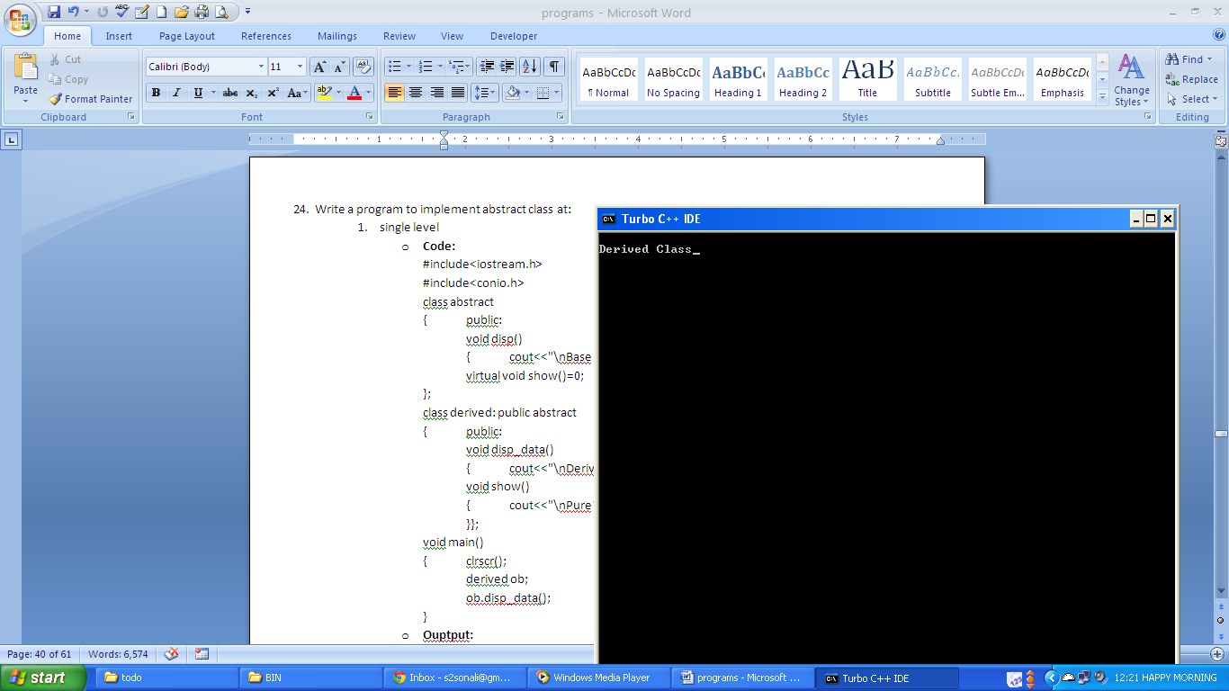

1. **Multilevel**
   * **Code:**

#include<iostream.h>

#include<conio.h>

class base

{

public:

void disp()

{ cout<<"\nBase Class"; }

virtual void disp1()=0;

};

class derived1: public base

{

public:

void disp2()

{ cout<<"\nDerived Class 1."; }

void disp1()

{ cout<<"\nPure Vitual Function 1."; }

virtual void disp3()=0;

};

class derived2: public derived1

{

public:

void disp4()

{ cout<<"\nDerived Class 2."; }

void disp3()

{ cout<<"\nPure Virtual Function 2."; }

};

void main()

{ clrscr();

derived2 ob;

ob.disp();

ob.disp1();

ob.disp2();

ob.disp3();

ob.disp4();

}

* + **Output:**

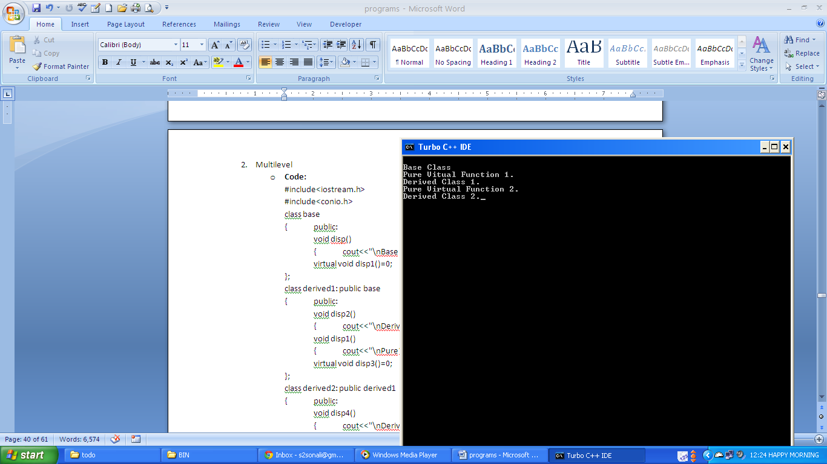

1. **Write a program to implement method overriding/ dynamic polymorphism/ run time polymorphism.**
   * + **Code:**

#include<iostream.h>

#include<conio.h>

class over

{ public:

virtual void disp()

{ cout<<"\nClass Over."; }

void disp1()

{ cout<<"\nClass Over Another Function"; }

void disp2()

{ cout<<"\nNon Virtual Function"; }

};

class virtual_func:public over

{ public:

void show()

{ cout<<"\nClass Virtual_func"; }

void disp()

{ cout<<"\nOverriding Func."; }

void disp2()

{ cout<<"Hello Student."; }

};

void main()

{ clrscr();

over *ptra;

over oba;

virtual_func obb;

ptra= &oba;

ptra->disp();

ptra->disp1();

ptra->disp2();

ptra= &obb;

ptra->disp();

obb.show();

ptra->disp2();

}

* + - **Output:**

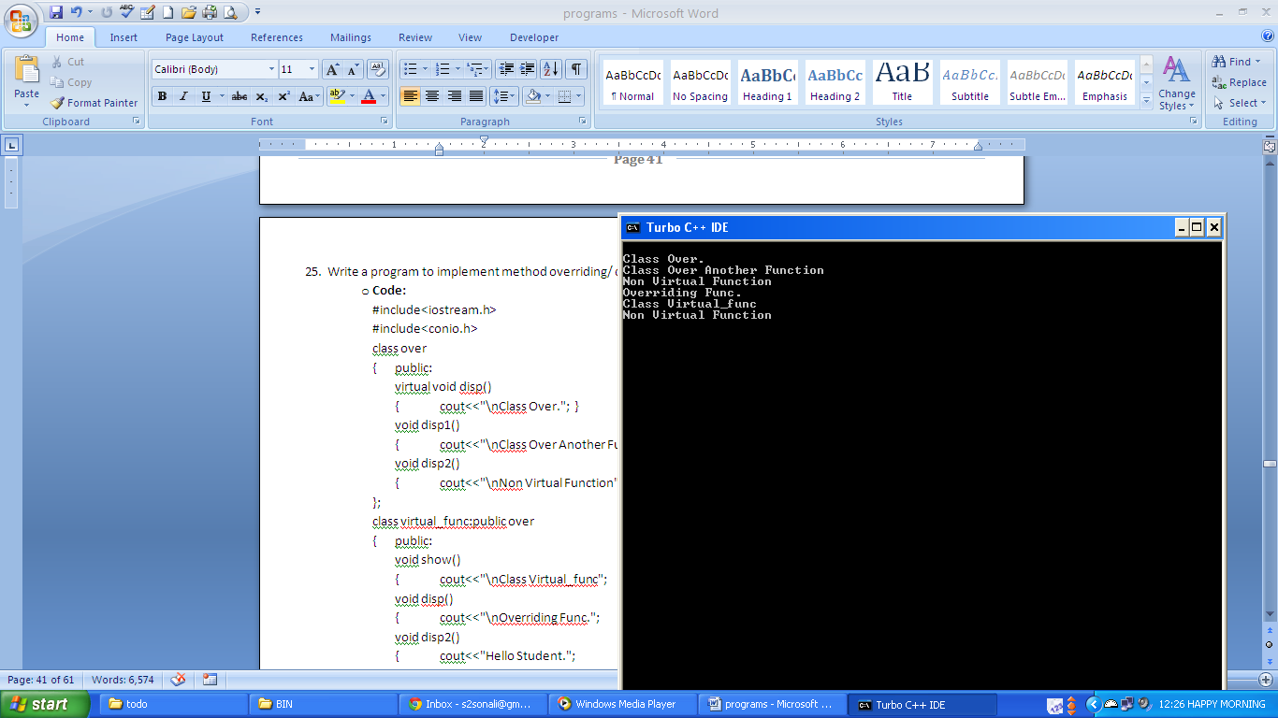

1. **Write a program to implement pointers to objects.**
   * + **Code:**

#include<iostream.h>

#include<conio.h>

class add

{

int a,b;

public:

void getdata(int a,int m)

{

this->a=a;

b=m;

}

int sum()

{

return (a+b);

}

void disp()

{

cout<<"sum of "<<a<<" and "<<b<<" is:"<<sum();

}

};

void main()

{

add ob;

add *obp;

obp=&ob;

obp->getdata(3,4);

obp->disp();

}

* + - **Output:**

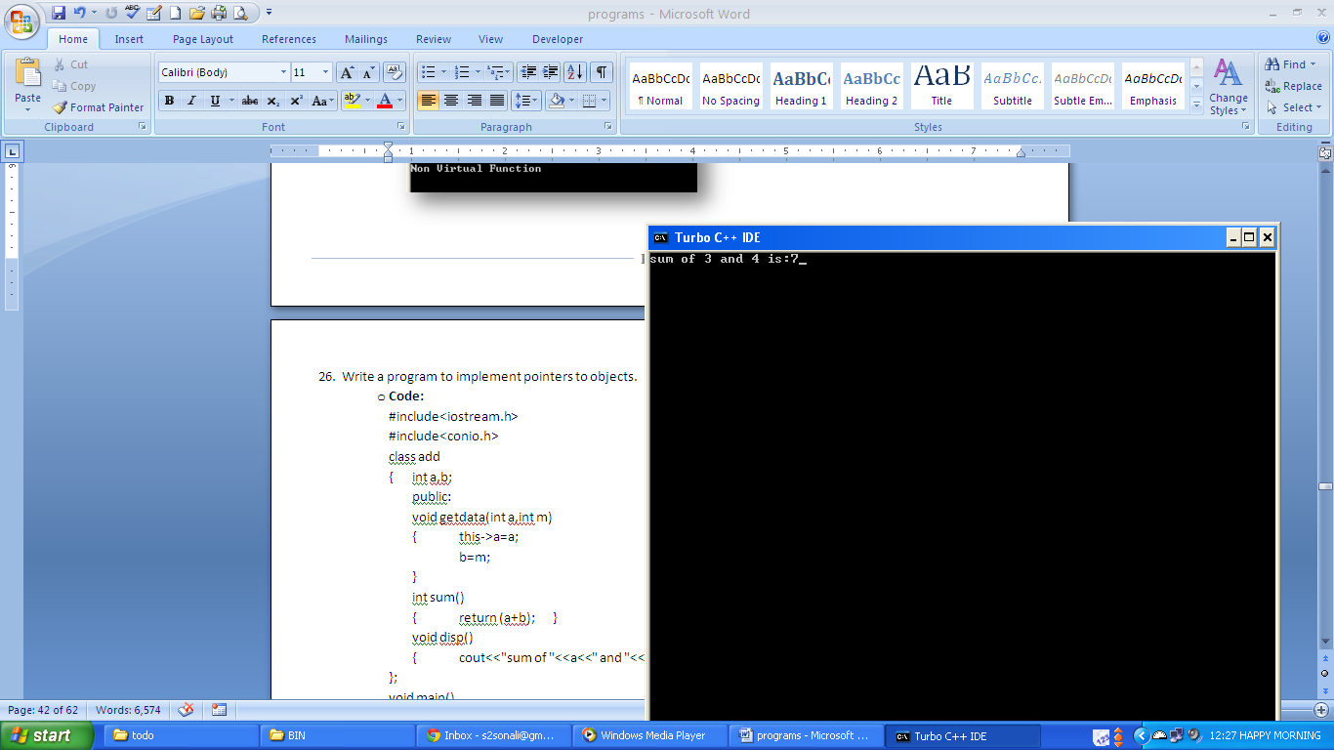

1. **Write a program to print sum of array elements using pointers.**
   * + **Code:**

#include<iostream.h>

#include<conio.h>

void main()

{

clrscr();

int arr[]={10,20,30,40,50};

int *ptrarr;

int sum=0;

ptrarr=arr;

for(int i=0;i<5;i++)

{

sum=sum+(*ptrarr);

ptrarr++;

}

cout<<"\n sum is:"<<sum;

}

* + - **Output:**

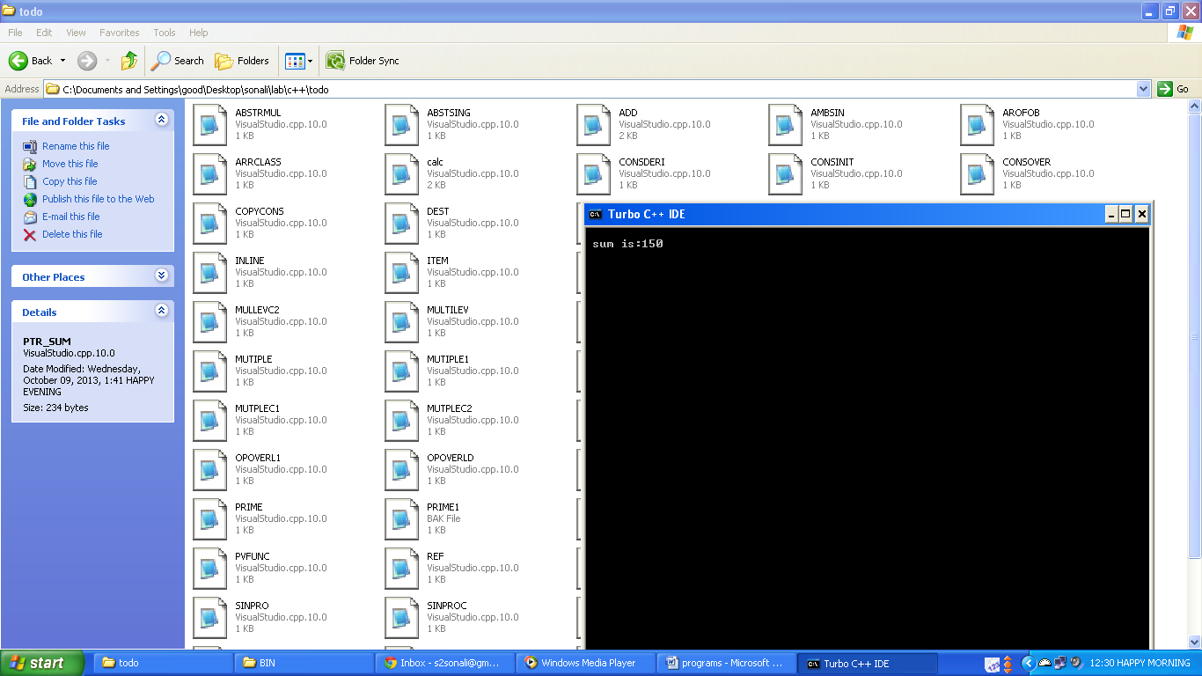

1. **Write a program to calculate simple interest using friend function. Function calculating simple interest and display simple interest must be declared as a friend function.**
   * + **Code:**

#include<iostream.h>

#include<conio.h>

class SI

{

int p,t;

float r;

public:

void getdata(int x,int y,float z)

{

p=x;

t=y;

r=z;

}

friend float interest(SI ob)

{

float s;

s=(ob.p*ob.t*ob.r)/100;

return s;

}

void disp()

{

cout<<"Simple Interest: ";

}

};

void main()

{

clrscr();

SI ob;

ob.getdata(2000,2,5.5f);

float a=interest(ob);

ob.disp();

cout<<a;

}

* + - **Output:**

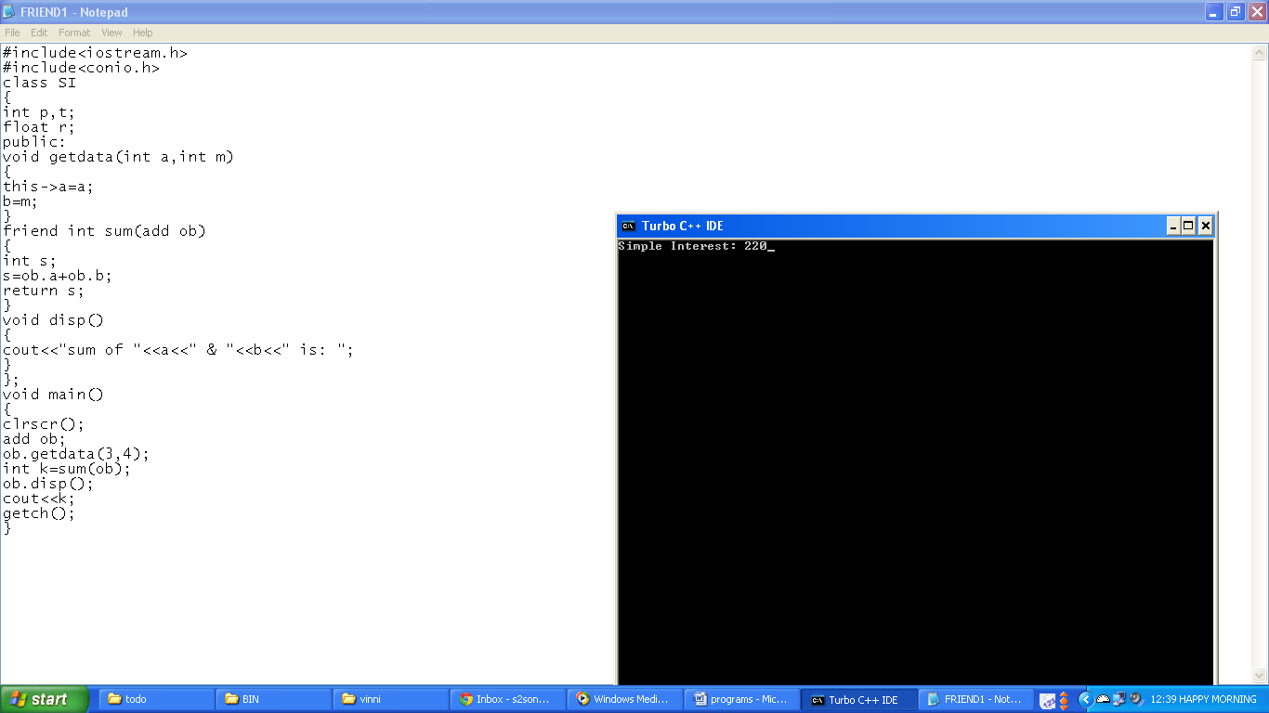

1. **Write a program to print the sum of two objects using pointers to data members and pointers to member function.**
   * + **Code:**

#include<iostream.h>

#include<conio.h>

class sum

{ int a,b;

public:

void getdata(int a,int b)

{ this->a=a;

this->b=b;

}

void calc(sum ob1,sum ob2)

{ int sum::*ptra=&sum::a;

int sum::*ptrb=&sum::b;

a=ob1.*ptra+ob2.*ptra;

b=ob1.*ptrb+ob2.*ptrb;

}

void disp()

{ cout<<"\nvalue of a:"<<a;

cout<<"\nvalue of b:"<<b;

}};

void main()

{ clrscr();

sum ob1,ob2,ob3;

void (sum::*ptr_getdata)(int,int)=&(sum::getdata);

void (sum::*ptr_disp)()=&(sum::disp);

(ob1.*ptr_getdata)(2,6);

(ob2.*ptr_getdata)(4,5);

cout<<"\nFor object 1:";

(ob1.*ptr_disp)();

cout<<"\nFor object 2:";

(ob2.*ptr_disp)();ob3.calc(ob1,ob2);

cout<<"\nsum of object 1 and object 2 is:";

(ob3.*ptr_disp)();

}

* + - **Output:**

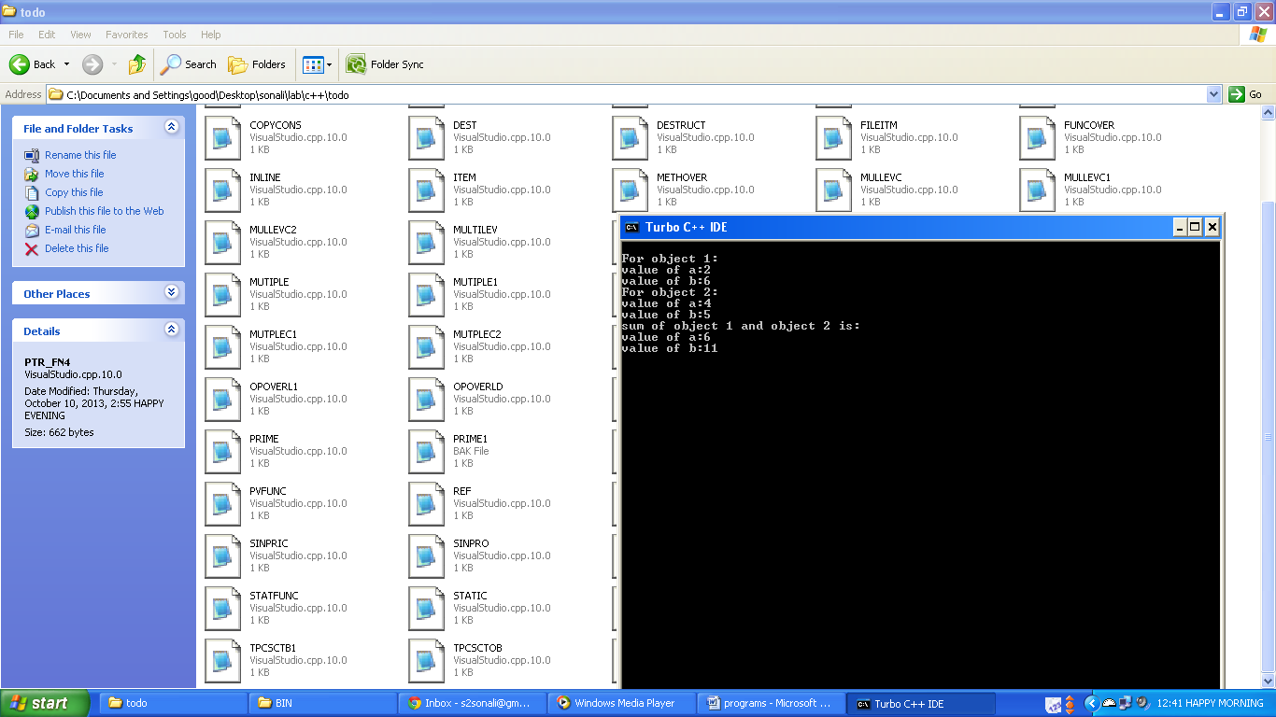

1. **Write a program to calculate sum of two objects using pointer to member function, pointer to data members. Class must have three instance variables. First two instance variables should hold the values and third instance variables should hold 1 if sum of first two values is even otherwise 0. Function calculating sum of objects must have one argument.**
   * + **Code:**

#include<iostream.h>

#include<conio.h>

class sum

{ int a,b,c;

public: void getdata(int a,int b)

{ this->a=a; this->b=b;

if((a+b)%2==0)

c=1;

else

c=0;

}

sum cal(sum o1)

{ sum o2;

int sum :: *ptra=& sum :: a;

int sum :: *ptrb=& sum :: b;

int sum :: *ptrc=& sum :: c;

o2.*ptra=a+o1.*ptra; o2.*ptrb=b+o1.*ptrb;

o2.*ptrc=c+o1.*ptrc; return o2;

}

void disp(sum o1, sum o2)

{ cout<<"Sum of "<<o1.a<<" and "<<o2.a<<" is "<<a<<".";

cout<<"\nSum of "<<o1.b<<" and "<<o2.b<<" is "<<b<<".";

cout<<"\nSum of "<<o1.c<<" and "<<o2.c<<" is "<<c<<".";

}};

void main()

{ clrscr();

sum ob,ob1,ob2;

void (sum :: *ptr_data)(int,int)=& sum :: getdata;

sum (sum :: *ptr_calc)(sum)=& sum :: cal;

void (sum :: *ptr_disp)(sum,sum)=& sum :: disp;

(ob.*ptr_data)(40,30); (ob1.*ptr_data)(50,10);

ob2=(ob.*ptr_calc)(ob1);(ob2.*ptr_disp)(ob,ob1);

}

* + - **Output:**

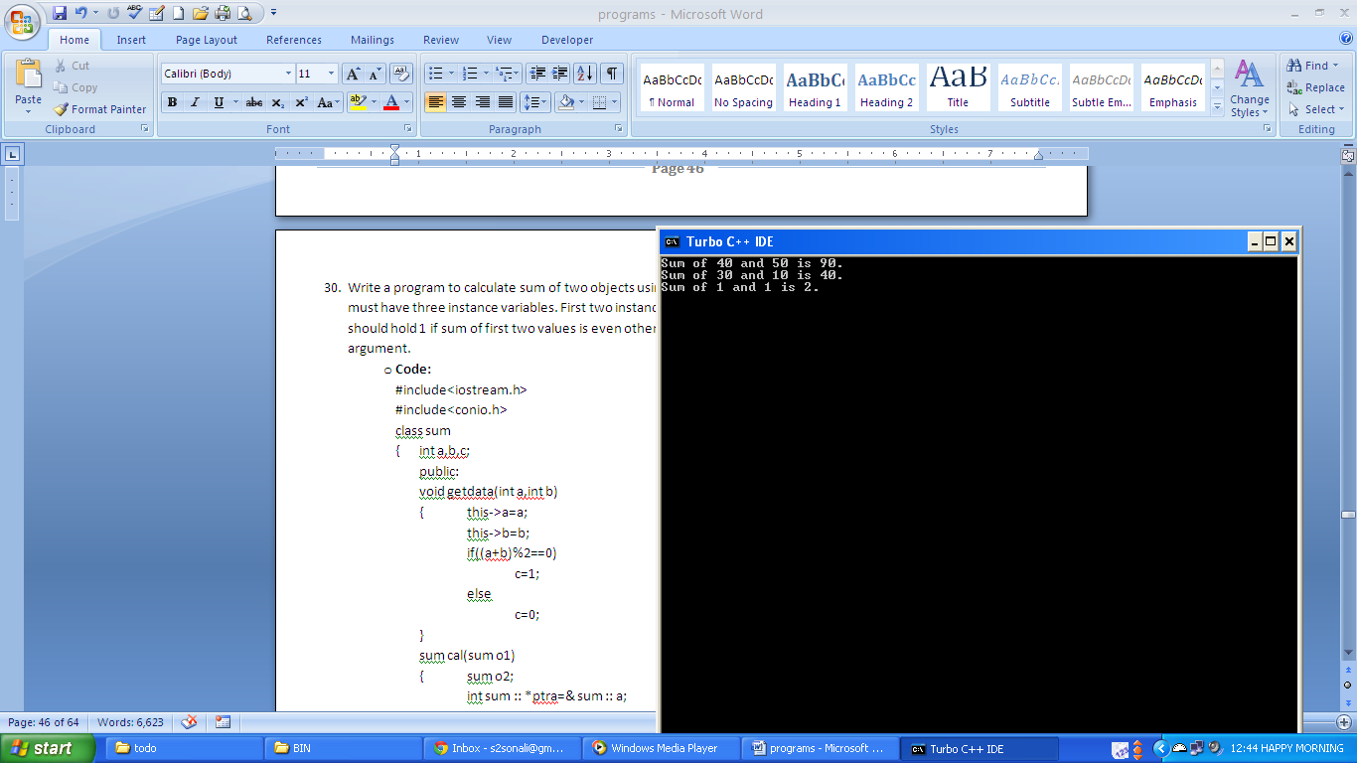

1. **Write a program to create a class item to store code of item and price of item. Write a function to compare two items and return that item whose price is greater.**
   * + **Code:**

#include<iostream.h>

#include<conio.h>

class greater

{ int a;

public:

void getdata(int a)

{ this->a=a;}

greater large( greater ob1)

{ if (a>ob1.a)

{ return *this;}

else

{ return ob1;}

}

void disp()

{ cout<<"\nvalue of a:"<<a;}

};

void main()

{ clrscr();

greater ob1,ob2;

void (greater::*ptr_getdata)(int)=&(greater::getdata);

void (greater::*ptr_disp)()=&(greater::disp);

(ob1.*ptr_getdata)(4);

(ob2.*ptr_getdata)(6);

cout<<"\nFor object 1:";

(ob1.*ptr_disp)();

cout<<"\nFor object 2:";

(ob2.*ptr_disp)();

ob2=ob2.large(ob1);

cout<<"\nlarger of object 1 and object 2 is:";

(ob2.*ptr_disp)();

getch();

}

* + - **Output:**

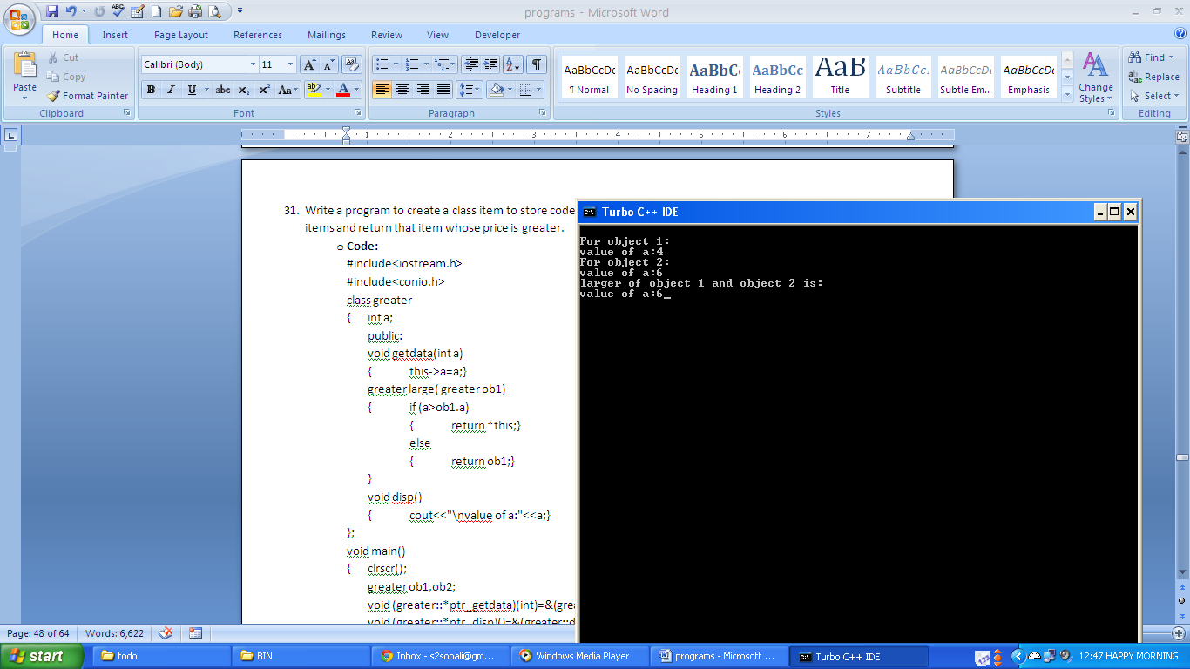

1. **Write a program to print the negation of objects using operator overloading using friend function and without friend function.**
   * **With Friend Function**
     + **Code:**

#include<iostream.h>

#include<conio.h>

class op_overload

{ int a,b;

public:

op_overload()

{ }

op_overload(int m, int n)

{ a=m;

b=n;

}

void disp()

{ cout<<"a:"<<a<<"\nb:"<<b; }

friend op_overload operator-(op_overload ob);

};

op_overload operator-(op_overload ob)

{ op_overload ob1;

ob1.a=-ob.a;

ob1.b=-ob.b;

return ob1;

}

void main()

{ clrscr();

op_overload ob(5,4),ob2;

cout<<"Before Negation.\n";

ob.disp();

ob2=-ob;

cout<<"\nAfter Negation.\n";

ob2.disp();

}

* + - **Output:**

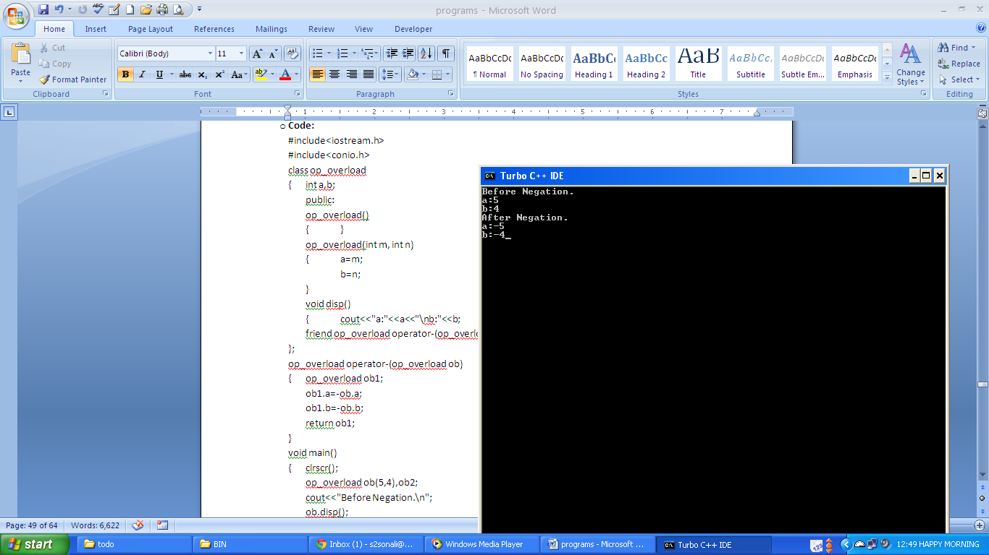

* + **Without Friend Function**
    - **Code:**

#include<iostream.h>

#include<conio.h>

class op_overload

{ int a,b;

public:

op_overload()

{ }

op_overload(int m, int n)

{ a=m;

b=n;

}

void disp()

{ cout<<"a:"<<a<<"\nb:"<<b; }

op_overload operator-();

};

op_overload op_overload:: operator-()

{ op_overload ob1;

ob1.a=-a;

ob1.b=-b;

return ob1;

}

void main()

{ clrscr();

op_overload ob(5,4),ob2;

cout<<"Before Negation.\n";

ob.disp();

ob2=-ob;

cout<<"\nAfter Negation.\n";

ob2.disp();

}

* + - **Output:**

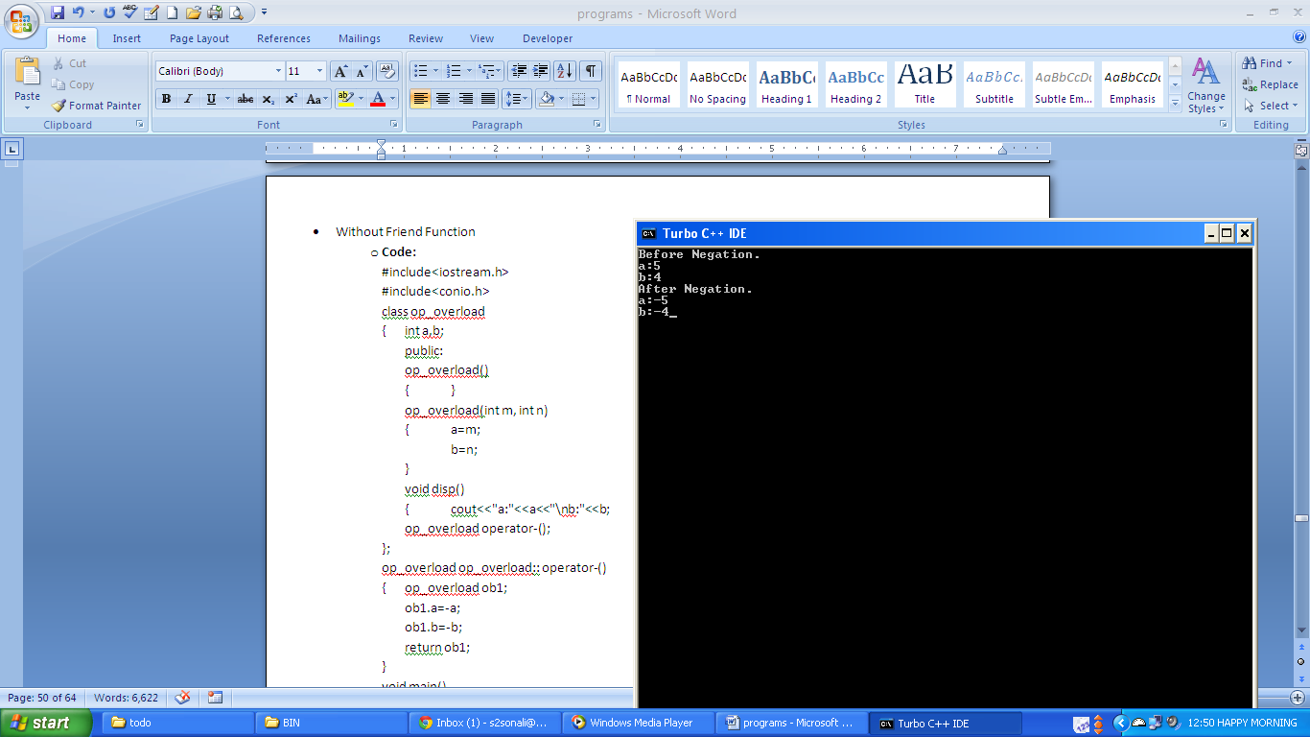

1. **Write a program to overload less than operator. Create a class student to store student roll number and percentage. After overloading less than operator, it should return which student has less percentage.**
   * + **Code:**

#include<iostream.h>

#include<conio.h>

class student

{ int roll;

float per;

public:

student(){}

student(int r,float p)

{ roll=r;

per=p;

}

friend student operator<(student o1,student o2);

void disp()

{ cout<<"roll: "<<roll<<"\npercentage: "<<per; }

};

student operator<(student o1,student o2)

{ if(o1.per<o2.per)

return o1;

else

return o2;

}

void main()

{ clrscr();

student ob(1,60.5f),ob1(2,70.5f),ob2;

cout<<"Student 1:\n";

ob.disp();

cout<<"\nStudent 2:\n";

ob1.disp();

cout<<"\nStudent with less percent:\n";

ob2=ob<ob1;

ob2.disp();

}

* + - **Output:**

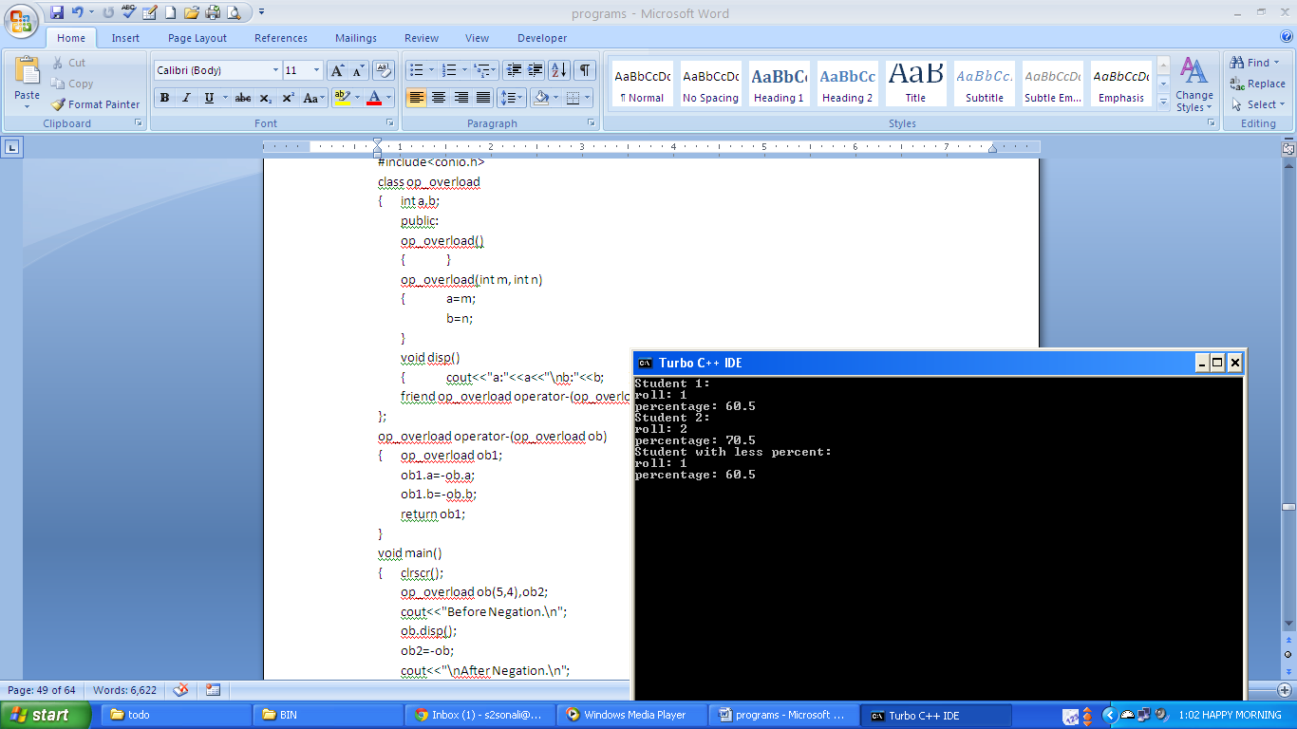

1. **Write a program to initialize the values to instance variables using initialization section of the constructor.**
   * + **Code:**

#include<iostream.h>

#include<conio.h>

class A

{ float a,b,c;

public:

A(int m,int n,int p)

{ a=m;

b=n;

c=p;

cout<<"a:"<<a<<"\nb:"<<b<<"\nc:"<<c;

}

A(int m,int n):a(m),b(n*2)

{ cout<<"\n\na:"<<a<<"\nb:"<<b; }

A(float m, float n):a(m+n),b(n),c(m*2)

{ cout<<"\n\na:"<<a<<"\nb:"<<b<<"\nc:"<<c; }

A(int m,float p):a(m+p),b(a+2),c(a-2)

{ cout<<"\n\na:"<<a<<"\nb:"<<b<<"\nc:"<<c; }

A(int m,int n,float p):c(n),b(p),a(m+n)

{ cout<<"\n\na:"<<a<<"\nb:"<<b<<"\nc:"<<c; }

};

void main()

{ clrscr();

A ob(2,3,4), ob1(2,3), ob2(6.2f,7.3f), ob3(5,5.5f), ob4(5,4,6.5f);

}

* + - **Output:**

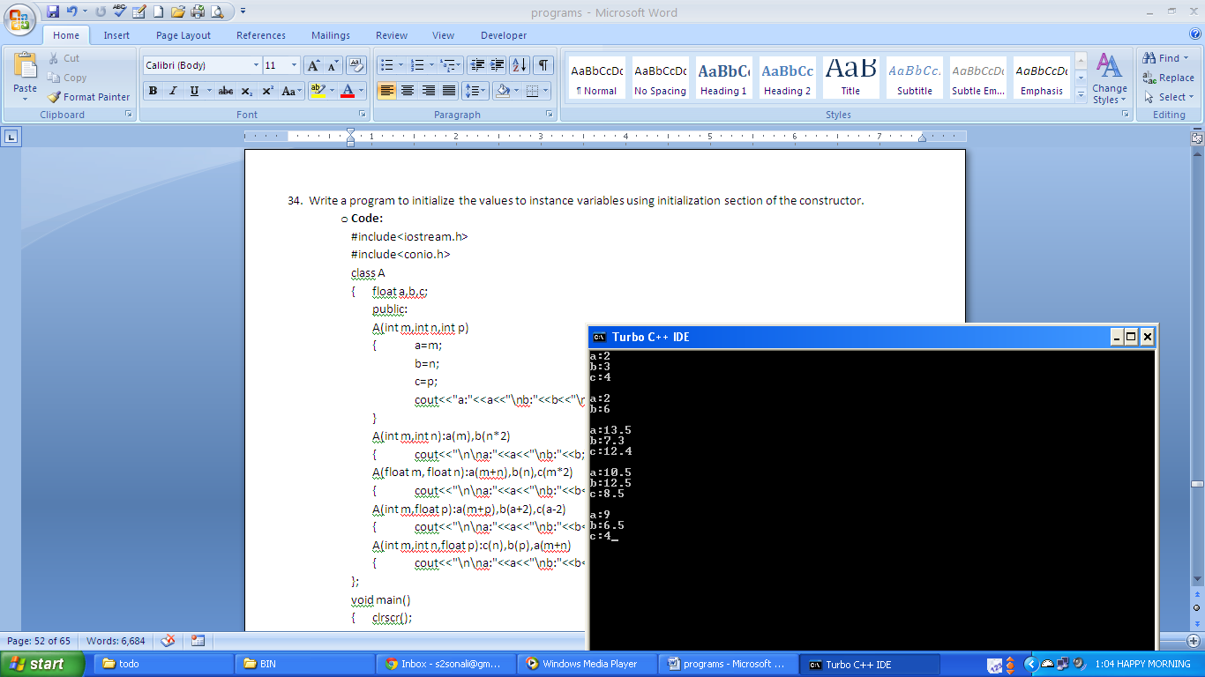

1. **Write a program to create a class item to store item code and price. Create another class quantity to store number of items needed by the user. Create class total_price which is derived from above classes. This class will display the total price to be paid by the user in order to get the desired quantity of item. Use constructor to initialize vales.** 
   * + **Code:**

#include<iostream.h>

#include<conio.h>

#include<string.h>

class item

{ protected:

char *code; float price;

public:

item(char *c, float p)

{ strcpy(code,c); price=p; }

void disp()

{ cout<<"Item Code: "<<code<<"\nItem Price: "<<price; }};

class quantity

{ protected:

int n;

public:

quantity(int n1)

{ n=n1; }

void display()

{ cout<<"\nNo. of Items: "<<n; }};

class total_price:public item, public quantity

{ int tp;

public:

total_price(char *c, float p, int n1):item(c,p),quantity(n1)

{ tp=p*n1; }

void displ()

{ cout<<"\nTotal Price to be paid: "<<tp; }

};

void main()

{ clrscr();

total_price ob("01",50.5f,5);

ob.disp();ob.display();

ob.displ();

}

* + - **Output:**

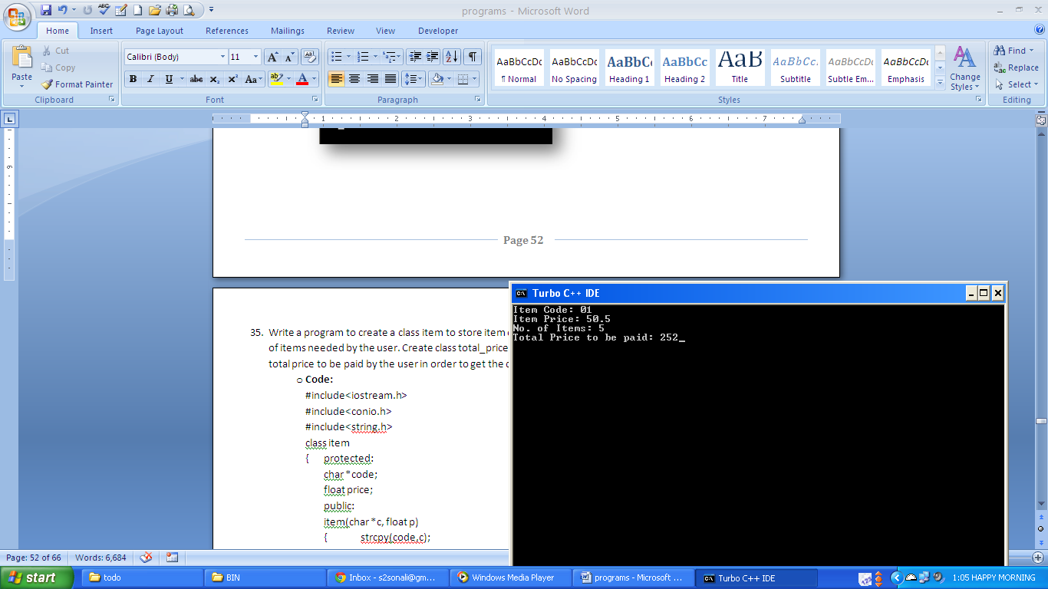

1. **Write a program to calculate total price of items being purchased by the user. Create a class item which stores the item code and its price. Create another class quantity to store the number of items required by the user. This class calculates the total price. Do not use inheritance to define the relationship these two classes.**
   * + **Code:**

#include<iostream.h>

#include<conio.h>

class item

{ public:

int code;

float price;

item(){}

item(int c,float p)

{ code=c;price=p;}

void display()

{ cout<<"\ncode:"<<code<<"\nprice:"<<price;}};

class quantity

{ public:

item i;

int no_item;

float total_p;

quantity(item ob,int n)

{ i.code=ob.code;i.price=ob.price;no_item=n;}

void calc()

{ total_p=(i.price*no_item);}

void disp()

{ cout<<"\nno. of items:"<<no_item<<"\ntotal price:"<<total_p;}};

void main()

{ item ob(1,20);quantity q(ob,50);

q.i.display();q.calc();q.disp();}

* + - **Output:**

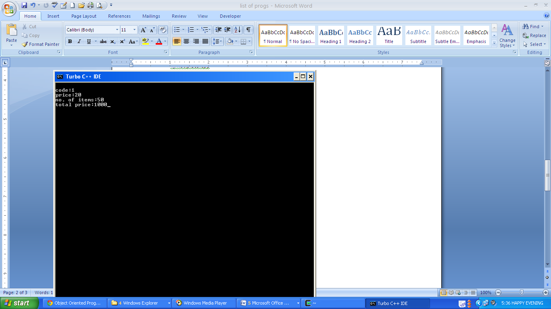

1. **Write a program to store student roll number and marks of three subjects. Convert this class to float data type that represents percentage of the student.**
   * + **Code:**

#include<iostream.h>

#include<conio.h>

class student

{ public:

int roll,s1,s2,s3;

student(int a,int b,int c,int d):roll(a),s1(b),s2(c),s3(d)

{ }

void disp()

{ cout<<"Roll No,: "<<roll;

cout<<"\nMarks 1: "<<s1;

cout<<"\nMarks 2: "<<s2;

cout<<"\nMarks 3: "<<s3;

}

operator float()

{ float p;

p=(s1+s2+s3)/3.0;

return p;

}};

void main()

{ clrscr();

student ob(1,90,90,90);

float per;

per=ob;

ob.disp();

cout<<"\n\nPercentage: "<<per;

}

* + - **Output:**

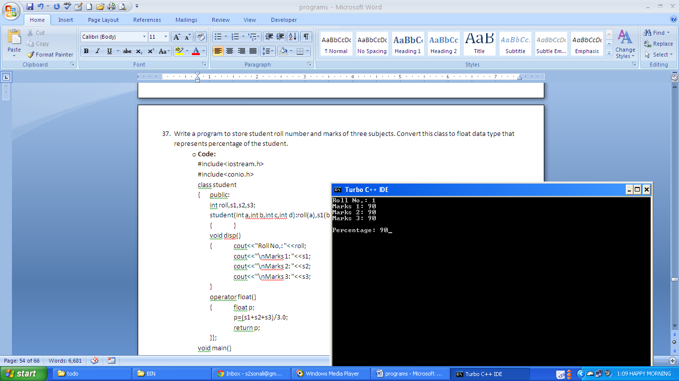

1. **Write a program to create a class vector to store marks of 5 students in the class. Convert this class to basic data type representing the average of the marks achieved by the class.**
   * + **Code:**

#include<iostream.h>

#include<conio.h>

class vector

{ public:

int a[3];

void get();void disp();

int sum();

operator float()

{ float avg;

int s=sum();

avg=s/3.0;

return avg; }};

void vector::get()

{ cout<<"Enter marks for:";

for(int i=0;i<3;i++)

{ cout<<"\nStudent "<<(i+1)<<":";cin>>a[i]; }}

void vector::disp()

{ for(int i=0;i<3;i++)

cout<<"\nMarks for student "<<(i+1)<<" is "<<a[i];}

int vector:: sum()

{ int s=0;

for(int i=0;i<3;i++)

s=s+a[i];

return s;}

void main()

{ vector ob;

ob.get(); float a=ob;

ob.disp(); cout<<"\n\nAverage: "<<a;

}

* + - **Output:**

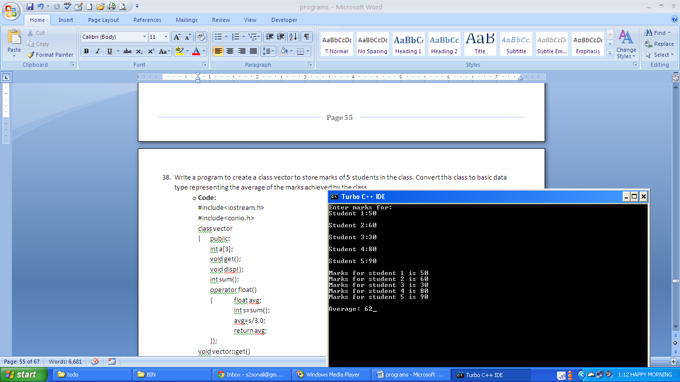

1. **Write a program to create a class student to store student roll number and marks of three subjects obtained by student. Convert student class type to percent class type to represent percentage achieved by the particular student. Use conversion function.**
   * + **Code:**

#include<iostream.h>

#include<conio.h>

class percent

{ public:

int roll;

float per;

void disp_per()

{ cout<<"\nPercentage of Roll No. "<<roll<<" is "<<per; }};

class student

{ public:

int roll, s1, s2, s3;

student(int a,int b,int c,int d)

{ roll=a; s1=b;

s2=c; s3=d;

}

void disp()

{ cout<<"Roll No.: "<<roll;

cout<<"\nMarks for subject 1: "<<s1;

cout<<"\nMarks for subject 2: "<<s2;

cout<<"\nMarks for subject 3: "<<s3;

}

operator percent()

{ percent p;

p.roll=roll; p.per=(s1+s2+s3)/3.0;

return p;

}};

void main()

{ percent pob;

student sob(1,80,80,80);

sob.disp();

pob=sob;

pob.disp_per();

}

* + - **Output:**

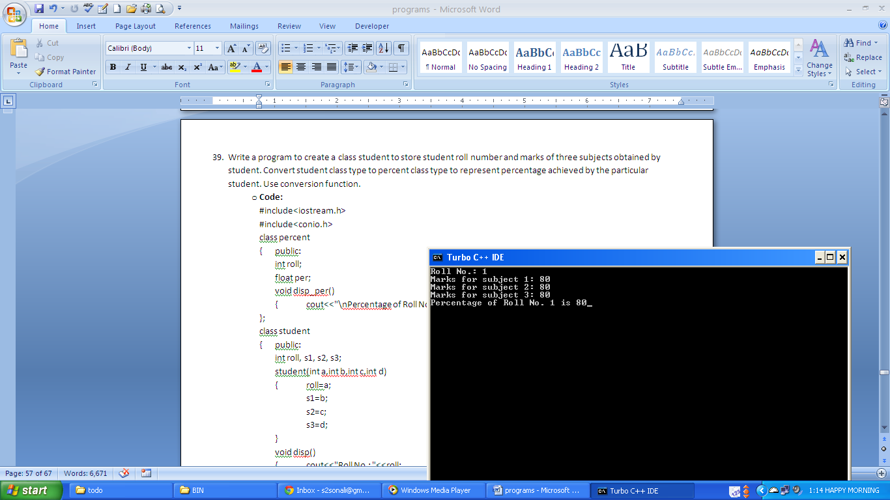

1. **Write a program to create a class item to store item code price and the quantity needed. Convert this class to total_price class to represent total price being paid by the user in order to get the desired quantity of particular item. Use conversion function.**
   * + **Code:**

#include<iostream.h>

#include<conio.h>

class total_price

{ public:

int code;

float tp;

void disp()

{ cout<<"\n\nTotal price to be paid for item "<<code<<" is "<<tp; }

};

class item

{ public:

int code,n;

float price;

item(int a,float b, int c)

{ code=a;

price=b;

n=c;

}

void display()

{ cout<<"Item Code: "<<code<<"\nPrice: "<<price<<"\nQuantity: "<<n;

}

operator total_price()

{ total_price p;

p.code=code;

p.tp=price*n;

return p; }};

void main()

{ total_price ob;

item ob1(1,50.0f,50);

ob1.display();

ob=ob1;

ob.disp();

}

* + - **Output:**

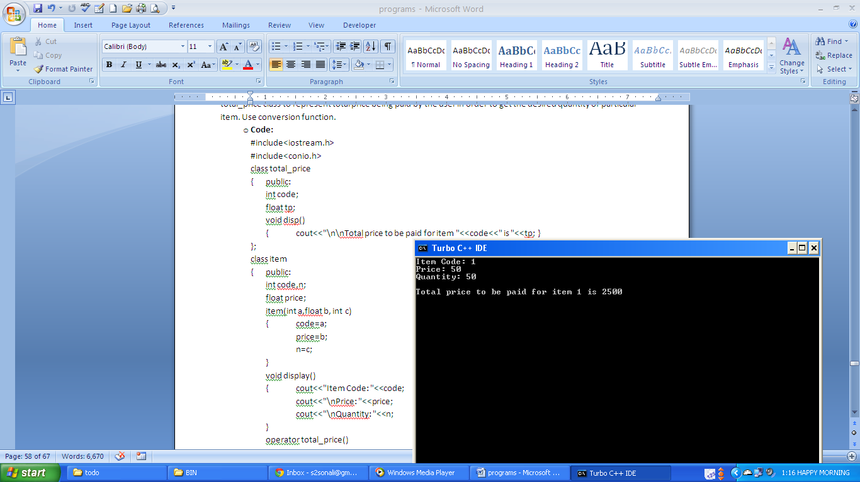

1. **Write a program to implement multiple inheritances. Create classes item and quantity. Item class stores description of the item. Quantity class stores number of items needed. Inherit class f_price from above classes. This class will represent total price being paid by the user.**

**Following criteria must be satisfied in the program:**

* + **Use only initialization section of the constructor to initialize the values.**
  + **Total price must be calculated in the member function.**
  + **Instance variable must be declared as private**
* **Code:**

#include<iostream.h>

#include<conio.h>

class item

{ int code; float price;

public: float get_price()

{ float p=price; return p; }

item(int c,float p) : code(c),price(p){}

void disp()

{ cout<<"Item Code:"<<code<<endl<<"\nItem Price:"<<price<<endl; }};

class quantity

{ int n;

public: int get_quantity()

{ return n; }

quantity(int b) : n(b){}

void disp1()

{ cout<<"\nItem needed by the User:"<<n<<endl; }};

class f_price : public item,public quantity

{ float t_price;

public:

f_price(int c,float p,int n) : item(c,p),quantity(n) {}

void total()

{ t_price=get_price()*get_quantity(); }

void disp2()

{ cout<<"\nTotal Price:"<<t_price; }};

void main()

{ f_price ob(101,50.0f,4);

ob.disp();ob.disp1();ob.total();ob.disp2();}

* **Output:**

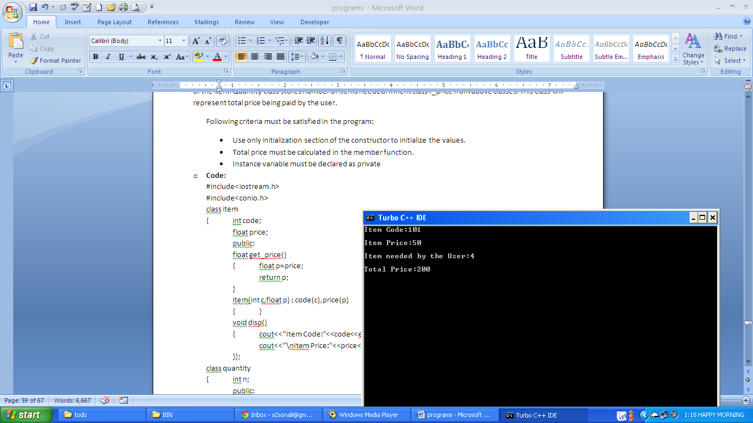

1. **Write a program to create a class student to store the roll number and marks of three subjects of a student. Convert this class to percent class which represents the percentage of the student. Use constructor to perform this type of conversion.** 
   * + **Code:**

#include<iostream.h>

#include<conio.h>

class student

{ int roll,n1,n2,n3;

public:

student(int r,int a,int b,int c):roll(r),n1(a),n2(b),n3(c){}

void disp()

{ cout<<"Roll no: "<<roll<<"\nMarks1: "<<n1<<"\nMarks2: "<<n2<<"\nMarks3: "<<n3;}

int sum_marks()

{int s=n1+n2+n3; return s;}

int get_roll()

{return roll;}

};

class percent

{

int roll;float per;

public:

percent(student ob)

{

roll=ob.get_roll();

per=ob.sum_marks()/3.0;

}

void disp()

{ cout<<"\nPercentage: "<<per;}};

void main()

{

clrscr();

student ob(1,30,40,90);

percent ob1(ob);

ob.disp();

ob1.disp();

}

* + - **Output:**

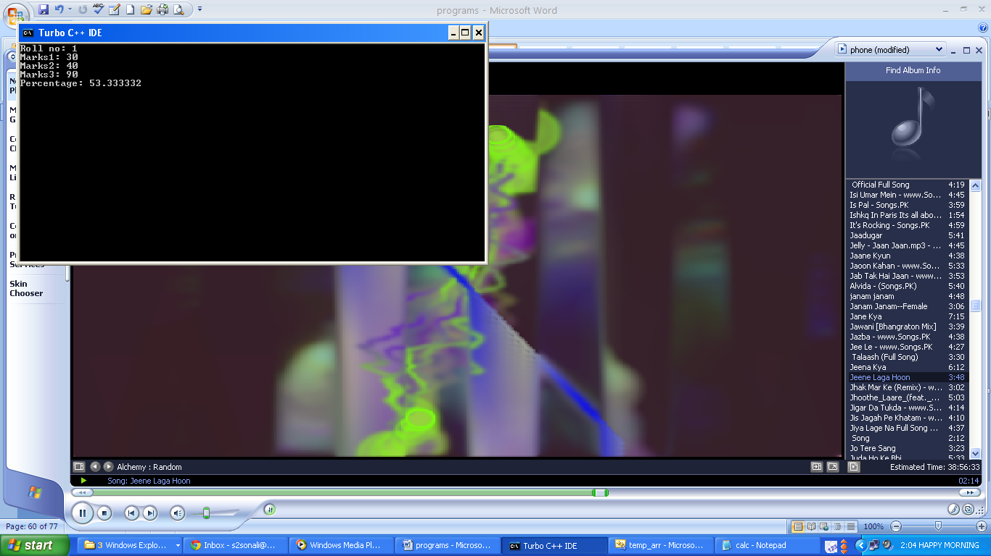

1. **Write a program to implement exception handling using try and catch block.** 
   * + **Code:**

#include "stdafx.h"

#include <iostream>

using namespace std;

void main()

{

int a;

float b,c;

cout<<"Enter values of a and b\n";

cin>>a>>b;

try

{

if(b!=0)

{

c=a/b;

cout<<a<<"/"<<b<<":"<<c;

}

else

{

throw b;

}

}

catch(int x)

{

cout<<"\nException Caught:"<<x;

}

catch(float x)

{

cout<<"\nFloat exception object caught:"<<x;

}

}

* + - **Output:**

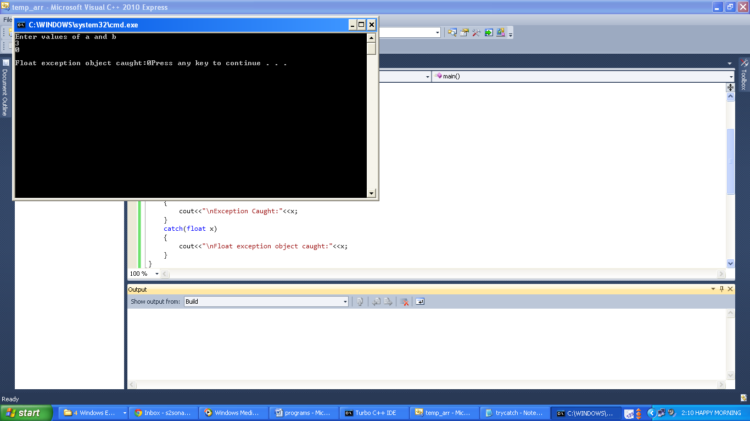

1. **Write a program to implement exception handling using try and multiple catch statements.**
   * + **Code:**

#include "stdafx.h"

#include <iostream>

using namespace std;

void mul_catch(int a)

{ try

{ if(a==0)

throw 'm';

else if(a==1)

throw 3;

else if(a==-1)

throw 3.5;

else if(a%2==0)

throw 2.6f;

cout<<"\nEnd try";

}

catch(char c)

{ cout<<"\nCharacter Caught:"<<c; }

catch(int c)

{ cout<<"\nInt Caught:"<<c; }

catch(float c)

{ cout<<"\nFloat Caught:"<<c; }

catch(double c)

{ cout<<"\nDouble caught:"<<c; }

cout<<"\nEnd of Function";

}

void main()

{ mul_catch(1);

mul_catch(2);

mul_catch(0);

mul_catch('a');

mul_catch(-1);

mul_catch(5);

cout<<"\nEnd of main function";

}

* + - **Output:**

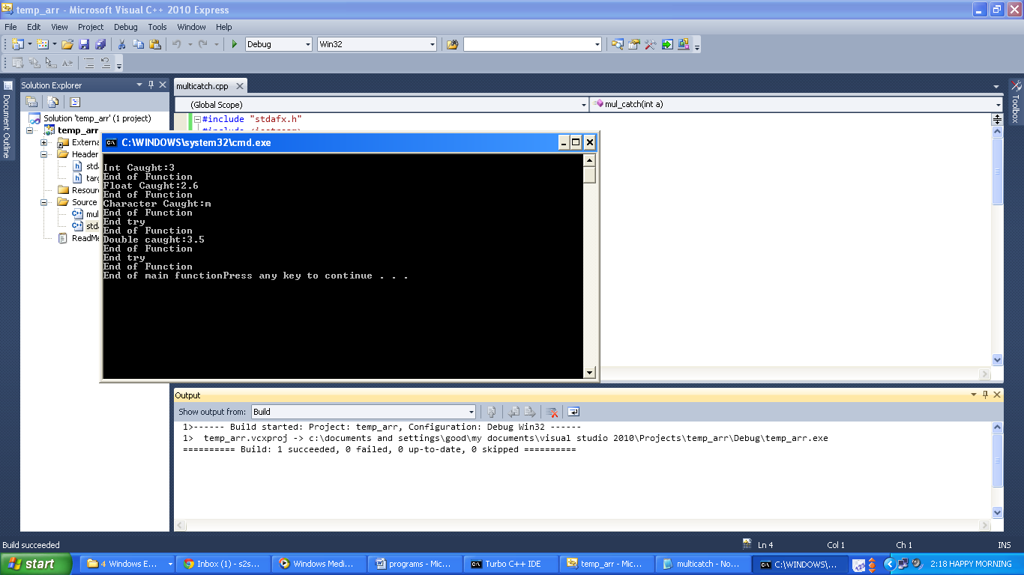

1. **Write a program to implement exception handling using try and catch block. Catch block should be able to handle all kinds of exceptions generated.** 
   * + **Code:**

#include "stdafx.h"

#include <iostream>

using namespace std;

void mul_catch(int a)

{ try

{ if(a==0)

throw 'm';

else if(a==1)

throw 3;

else if(a==-1)

throw 3.5;

else if(a%2==0)

throw 2.6f;

cout<<"\nEnd Try";

}

catch(...)

{ cout<<"\nException Caught."; }

cout<<"\nEnd of function";

}

void main()

{

mul_catch(1);

mul_catch(2);

mul_catch(0);

mul_catch('a');

mul_catch(-1);

mul_catch(5);

cout<<"End of main";

}

* + - **Output:**

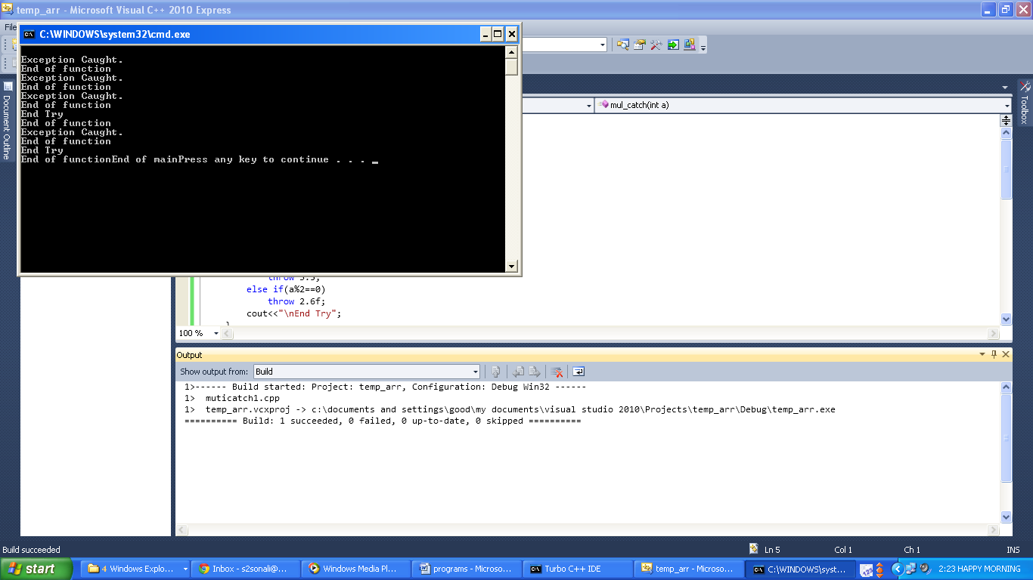

1. **Write a program to implement exception handling using try and catch block. In this the function generating exception should not handle it.**
   * + **Code:**

#include "stdafx.h"

#include <iostream>

using namespace std;

void divide(int a,int b)

{

float c;

if(b!=0)

{

c=a/(float)b;

cout<<c;

}

else

throw b;

}

void main()

{

try

{

divide(3,5);

divide(3,0);

}

catch(int k)

{cout<<"\nInteger Exception Object Caught "<<k;}

cout<<"\nEnd of main";

}

* + - **Output:**

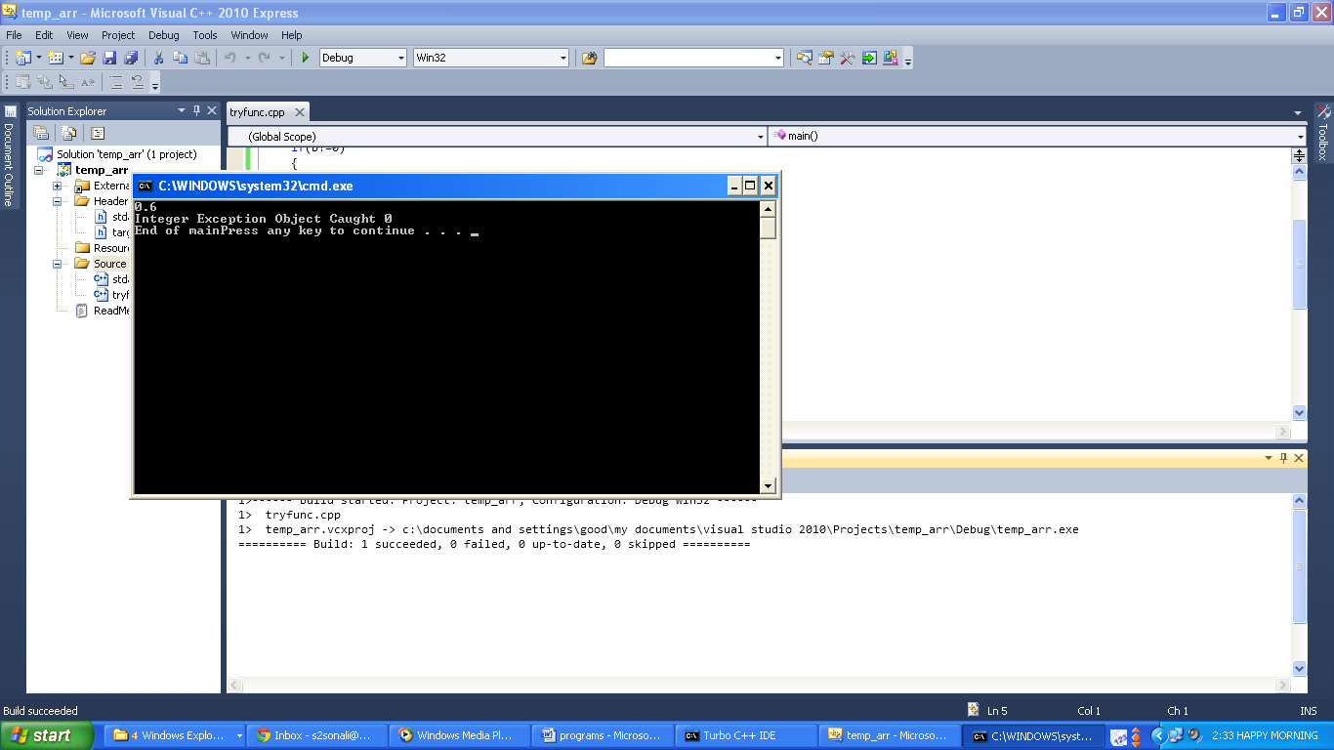

1. **Write a program to implement exception file handling using try and catch block, rethrowing the exception generated.**
   * + **Code:**

#include "stdafx.h"

#include<iostream>

using namespace std;

void divide(int a, int b)

{ float c;

try

{ if(b!=0)

{ c=a/(float)b;

cout<<a<<"/"<<b<<" is "<<c;

}

else

{ throw b; }

cout<<"\nEnd Try";

}

catch(int k)

{ cout<<"\nInt Exception caught";

throw;

}}

void main()

{ try

{ divide(3,5);

divide(3,0);

}

catch(int k)

{ cout<<"\nException rethrown is caught"; }

cout<<"\nEnd of main function";

}

* + - **Output:**

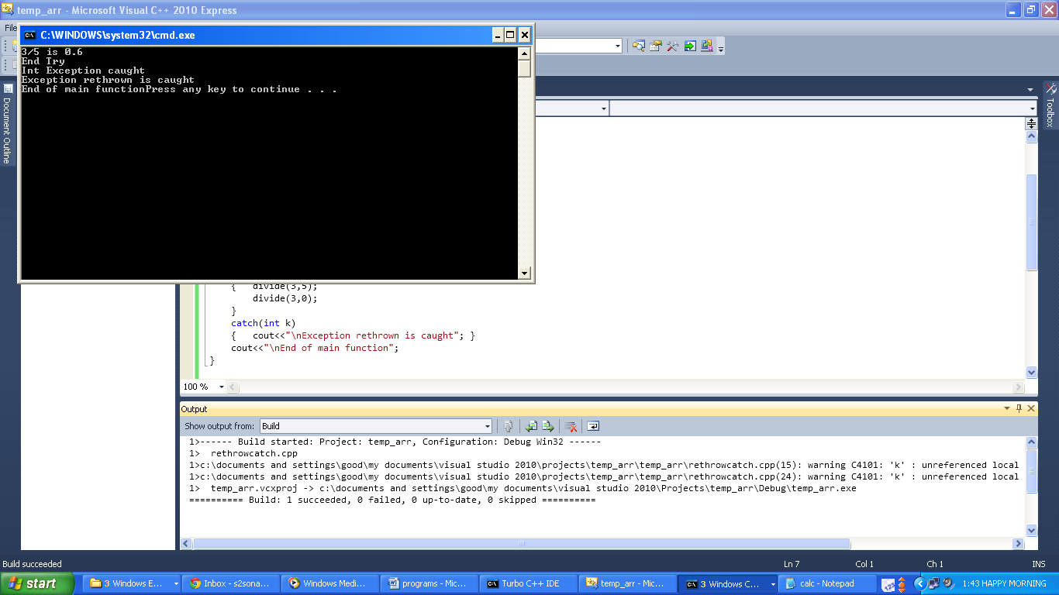

1. **Write a program to implement exception handling using nested try block.**
   * + **Code:**

#include "stdafx.h"

#include <iostream>

using namespace std;

void divide(int a, int b)

{ float c;

try

{ if(b!=0)

{ c=a/(float)b;

cout<<a<<"/"<<b<<" is "<<c;

}

else

{ throw b; }

}

catch(float k)

{ cout<<"Float Exception Caught: "<<k; }

}

void main()

{ try

{ divide(3,0);

divide(3,5);

}

catch(int k)

{ cout<<"\nInt Exception Object Caught:"<<k; }

}

* + - **Output:**

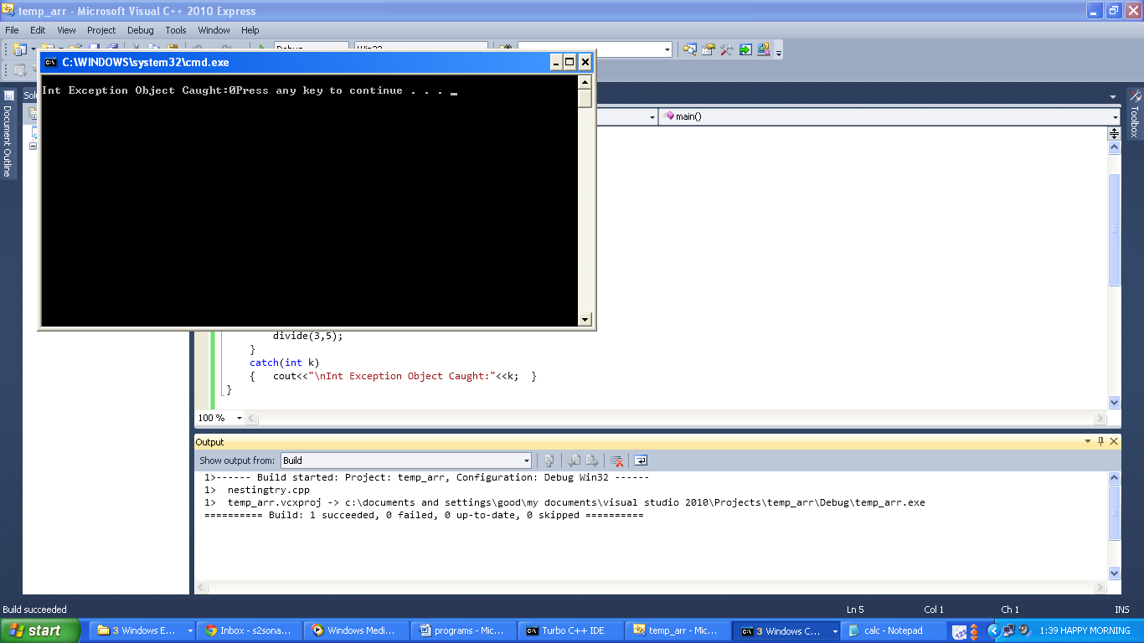

1. **Write a program to create a class arithmetic having functions to take to numbers from the user and performing addition, subtraction, multiplication or division according to the user’s choice. Use exception handling wherever required.**
   * + **Code:**

#include "stdafx.h"

#include <iostream>

using namespace std;

class arithmatic

{ int x,y;

public:

void getdata()

{ int a,b;

cout<<"Enter first number.\n";

cin>>a;

cout<<"\nEnter second number.\n";

cin>>b;

x=a;

y=b;

}

void disp()

{ cout<<"\n\nFirst Number: "<<x<<"\nSecond Number: "<<y;

}

void add()

{ cout<<"\nSum of "<<x<<" and "<<y<<" is "<<(x+y)<<"\n\n";

}

void sub()

{ cout<<"\nDifference of "<<x<<" and "<<y<<" is "<<(x-y)<<"\n\n";

}

void mul()

{ cout<<"\nProduct of "<<x<<" and "<<y<<" is "<<(x*y)<<"\n\n";

}

void div()

{ try

{ if(y!=0)

cout<<"\nQuotient of "<<x<<" and "<<y<<" is "<<(x/y)<<"\n\n";

else

throw y;

}

catch(...)

{ cout<<"\nDivision By Zero Exception:\n\n";

}

}};

void main()

{

arithmatic ob;

int a;

do

{ cout<<"Enter choice:\n\n1. Addition\n2. Subtraction\n3. Multiplication\n4. Division\n5. Exit\n";

cin>>a;

if(a<5)

{ switch(a)

{ case 1:

ob.getdata();

ob.disp();

ob.add();

break;

case 2:

ob.getdata();

ob.disp();

ob.sub();

break;

case 3:

ob.getdata();

ob.disp();

ob.mul();

break;

case 4:

ob.getdata();

ob.disp();

ob.div();

break;

default:

cout<<"\nInvalid Choice.\n";

break;

}

}

else

cout<<"\n\nYou are exited.\n";

}while(a<5);}

* + - **Output:**

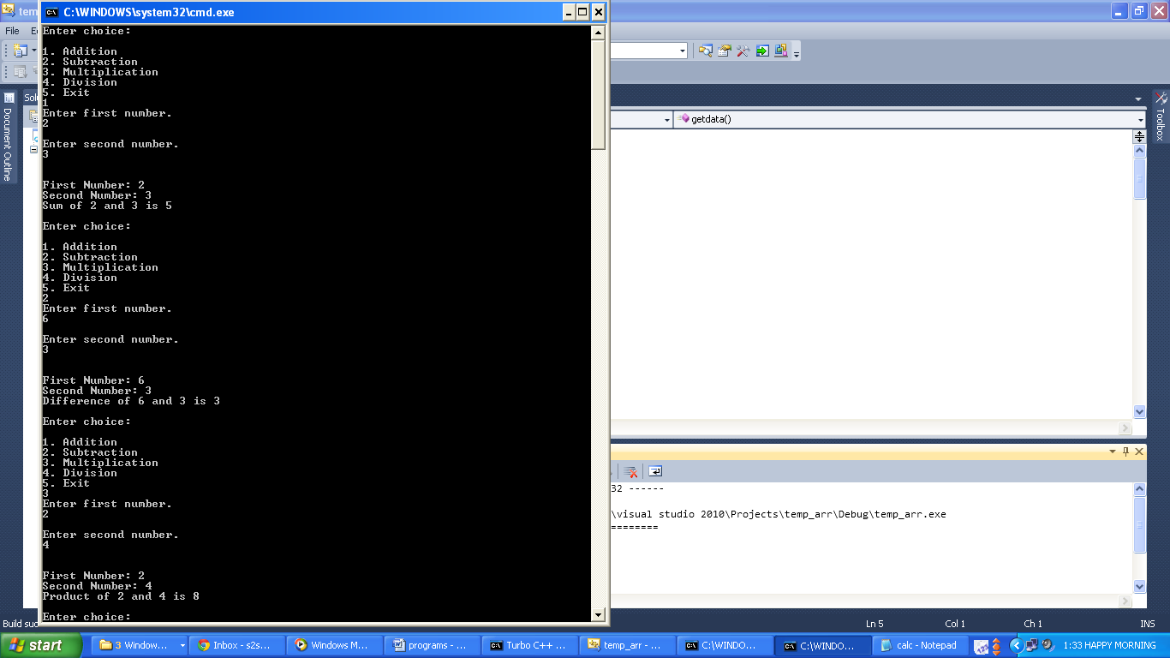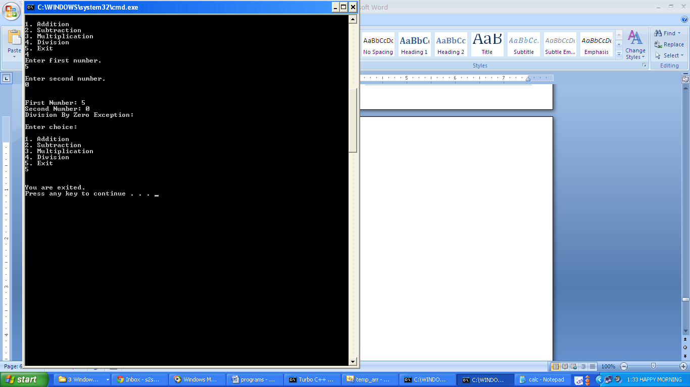

1. **Write a program to store roll number and marks of three subjects of a student in the file ‘stud’ and also perform read operation to print student details on the monitor.**
   * + **Code:**

#include<iostream.h>

#include<conio.h>

#include<fstream.h>

void main()

{

clrscr();

int roll,m1,m2,m3;

cout<<"\nEnter roll no.";

cin>>roll;

cout<<"\nEnter marks of 3 subjects\n";

cin>>m1>>m2>>m3;

ofstream ofile("stud");

ofile<<roll<<m1<<m2<<m3;

ofile.close();

ifstream ifile("stud");

ifile>>roll>>m1>>m2>>m3;

cout<<"\nRoll no.:"<<roll;

cout<<"\nMArks 1:"<<m1;

cout<<"\nMarks 2:"<<m2;

cout<<"\nMarks 3:"<<m3;

ifile.close();

getch();

}

* + - **Output:**

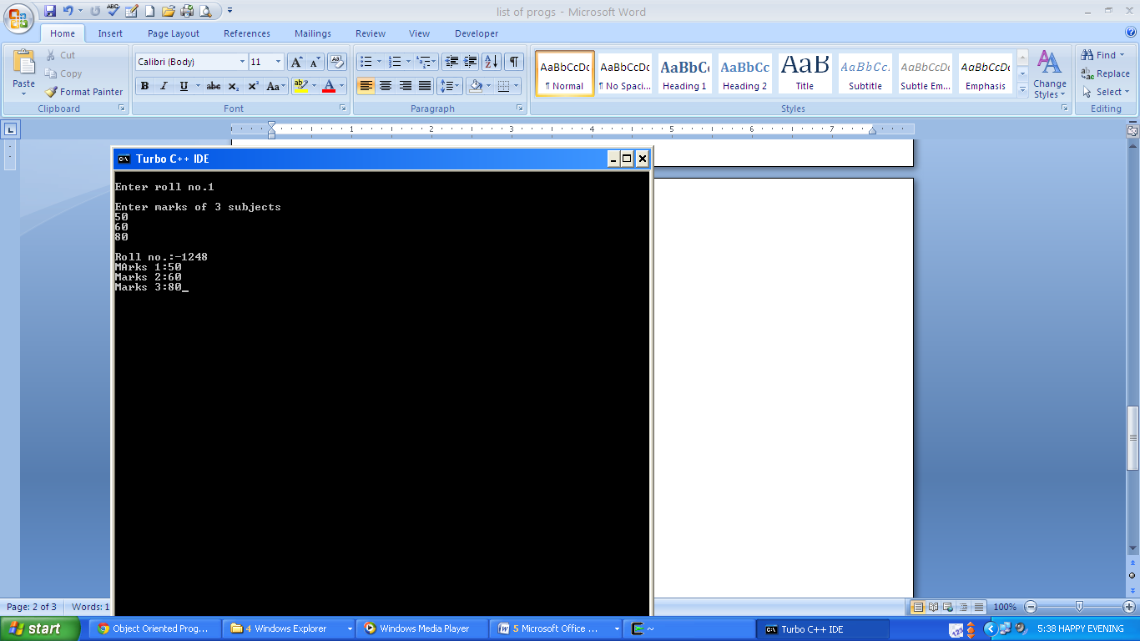

1. **Write a program to work with multiple files using open () function.** 
   * + **Code:**

#include<iostream.h>

#include<fstream.h>

void main()

{

ofstream ofile;

ofile.open("Book_author");

ofile<<"abcd\n";

ofile<<"efgh\n";

ofile<<"ijkl\n";

ofile.close();

ofile.open("Book_title");

ofile<<"OS\nHTML\nCA\n";

ofile.close();

const int size=30;

char arr[size];

ifstream ifile;

ifile.open("Book_author");

cout<<"\nBOOK AUTHORS:\n";

while(ifile)

{

ifile.getline(arr,size);

cout<<arr<<"\n";

}

ifile.close();

ifile.open("Book_title");

cout<<"\nBOOK TITLES\n";

while(ifile)

{

ifile.getline(arr,size);

cout<<arr<<"\n";

}

ifile.close();

}

* + - **Output:**

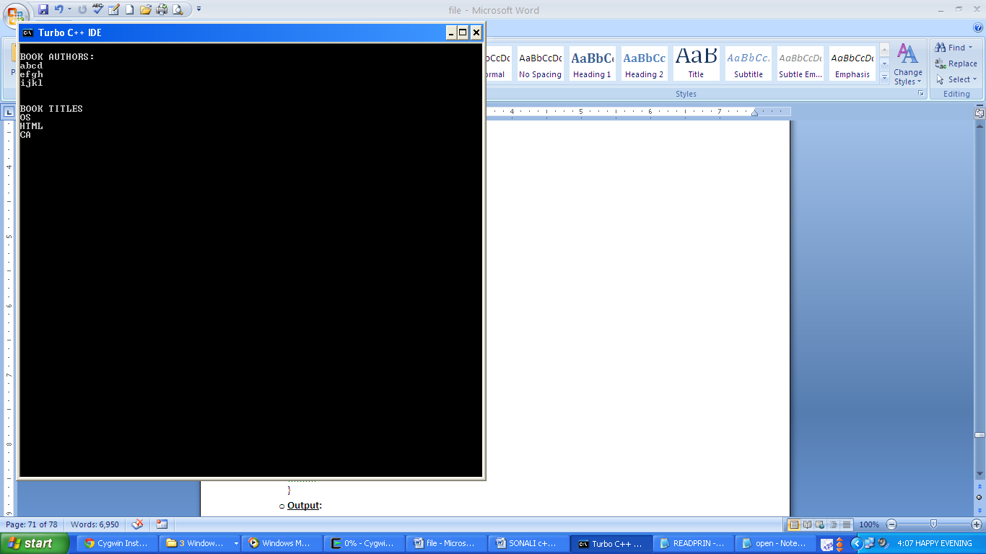

1. **Write a program to calculate total number of items and total price of all items stored in the file named item. The values stored in the item file must be entered through the keyboard.**
   * + **Code:**

#include<iostream.h>

#include<fstream.h>

#include<stdio.h>

void main()

{ int code,n=0;

float price, tp=0;

ofstream ofile;

ofile.open("item");

char ch='y';

while(ch=='y')

{ cout<<"enter itemcode:\n";cin>>code;

cout<<"\nenter price:\n";cin>>price;

ofile<<code<<"\n”<<price<<"\n";

cout<<"\nDo you want to enter more items info (y/n)";

cin>>ch;}

ofile.close();

ifstream ifile;

ifile.open("item");

while(ifile)

{ ifile>>code;

cout<<"\nitem code:"<<code;

n++;

ifile>>price;

cout<<"\nPrice:"<<price;

tp=tp+price;}

cout<<"\ntotal number of items:"<<n<<"\nTotal price:"<<tp;

ifile.close();}

* + - **Output:**

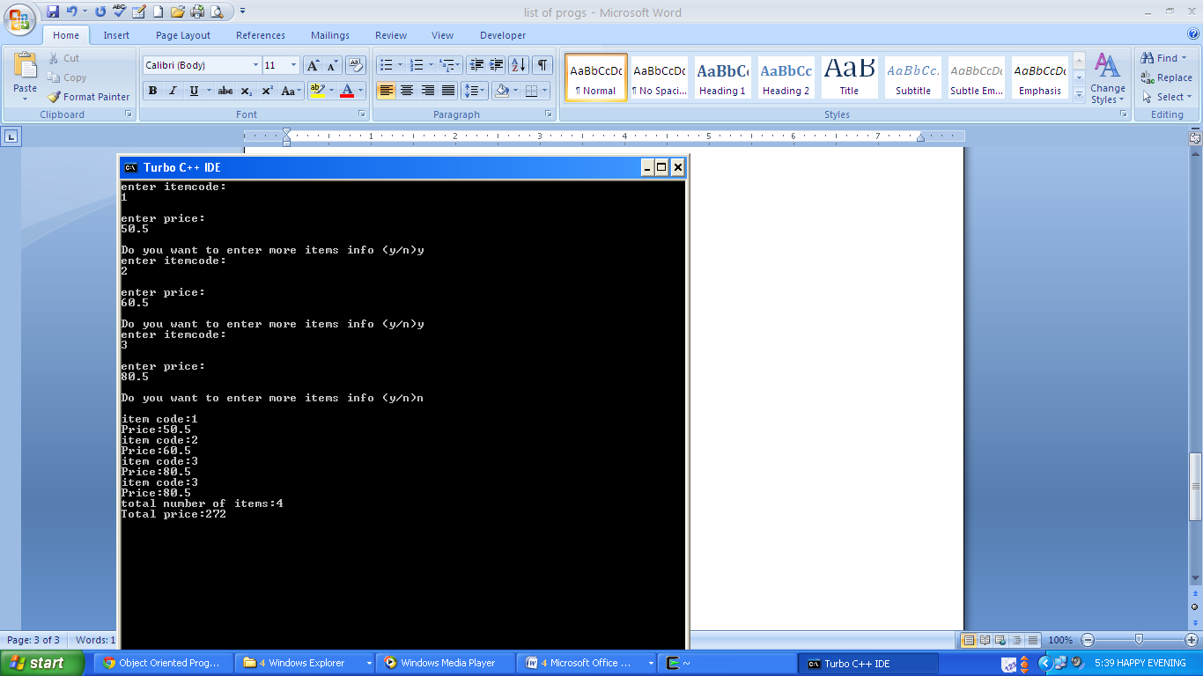

1. **Write a program to create a binary file storing an array of 5 numbers. Write the data to the file and read it using write () and read () functions.** 
   * + **Code:**

#include<iostream.h>

#include<conio.h>

#include<fstream.h>

void main()

{

clrscr();

int arr[5]={1,2,3,4,5};

ofstream ofile;

ofile.open("binary");

ofile.write((char*)&arr,sizeof(arr));

ofile.close();

for(int i=0;i<5;i++)

arr[i]=0;

ifstream ifile;

ifile.open("binary");

ifile.read((char*)&arr,sizeof(arr));

for(i=0;i<5;i++)

cout<<arr[i]<<"\n";

ifile.close();

getch();

}

* + - **Output:**

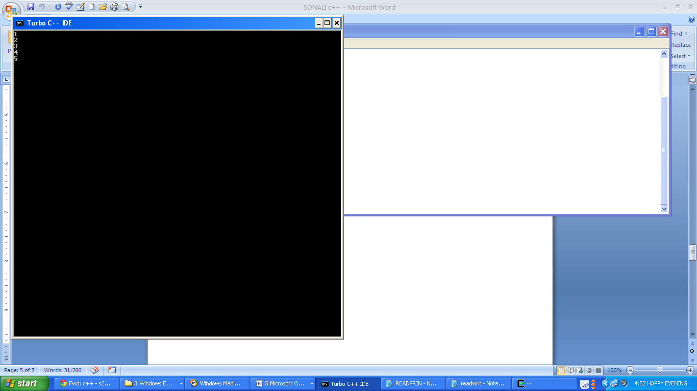

1. **Write a program to create a binary file student storing roll number and marks of three subjects of 5 students. Use read () and write () functions. Display formatted data on the screen setting appropriate width and alignments.**
   * + **Code:**

#include<iostream.h>

#include<fstream.h>

#include<iomanip.h>

class student

{

int roll,m1,m2,m3;

public:

void getdata();

void disp();

};

void student :: getdata()

{

cout<<"\nEnter roll no.:";

cin>>roll;

cout<<"\nEnter marks of subject 1:";

cin>>m1;

cout<<"\nEnter marks of subject 2:";

cin>>m2;

cout<<"\nEnter marks of subject 3:";

cin>>m3;

}

void student :: disp()

{

cout<<setiosflags(ios::left)<<setw(6)<<roll<<setiosflags(ios::right)<<setw(5)<<m1<<setw(5)<<m2<<setw(5)<<m3<<endl;

}

void main()

{

student s[2];

fstream iofile;

iofile.open("student",ios::in|ios::out);

cout<<"\nEnter student details for 5 students:";

for(int i=0;i<5;i++)

{ s[i].getdata();

iofile.write((char*)&s[i],sizeof(s[i]));

}

iofile.seekg(0);

cout<<"\nStudent details:\n";

for(i=0;i<5;i++)

{

iofile.read((char*)&s[i],sizeof(s[i]));

s[i].disp();

}

iofile.close();

}

* + - **Output:**

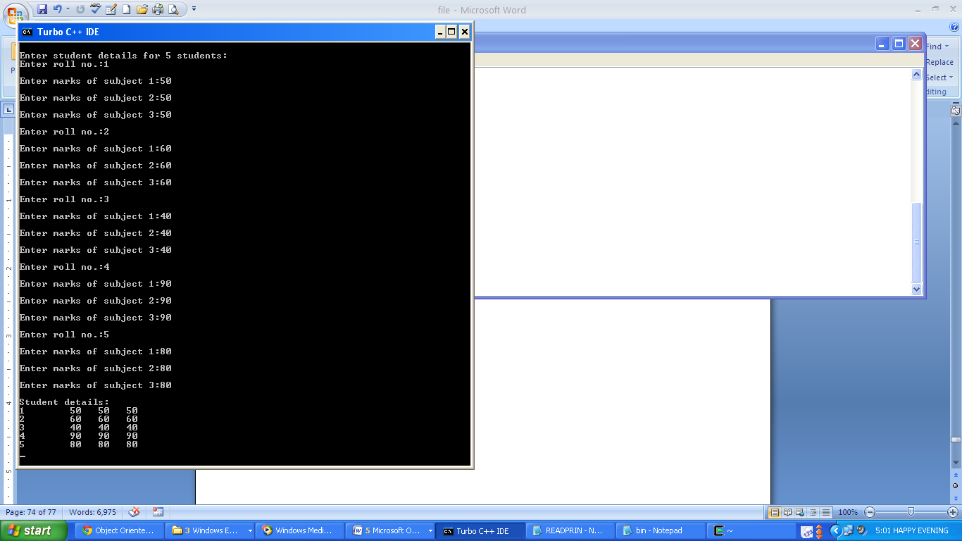

1. **Write a program to show the working of reference variable.**
   * + **Code:**

#include<iostream.h>

#include<conio.h>

void main()

{

clrscr();

int a=10;

int &b=a;

cout<<"Value of a="<<a<<" and value of b="<<b;

a=a+10;

cout<<"\nValue of a="<<a<<" and value of b="<<b;

b=b-10;

cout<<"\nValue of a="<<a<<" and value of b="<<b;

}

* + - **Output:**

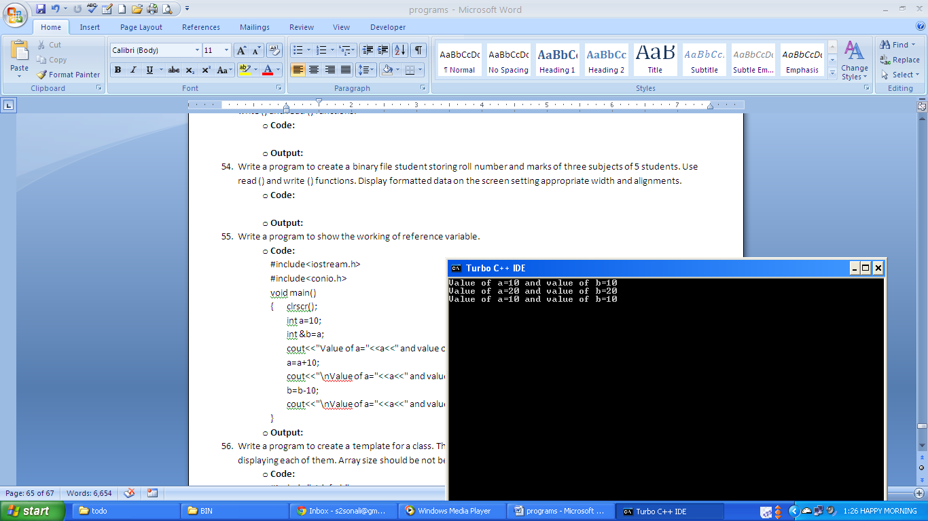

1. **Write a program to create a template for a class. The class should have functions to sum array elements and displaying each of them. Array size should be not being fixed.**
   * + **Code:**

#include "stdafx.h"

#include <iostream>

using namespace std;

template <class t1>

class arrsum

{ int size; t1 *ar;

public: arrsum(t1 *a,int m)

{ size=m; ar=new t1[size];

for(int i=0;i<size;i++)

ar[i]=a[i]; }

void disp()

{ for(int i=0;i<size;i++)

cout<<"ar["<<i<<"]: "<<ar[i]<<"\n"; }

t1 sum()

{ t1 sum=0; for(int i=0;i<size;i++)

sum=sum+ar[i];

return sum; }};

void main()

{ int a[]={1,2,3,4,5};

cout<<"Integer array:\n";arrsum <int> ob(a,5);

ob.disp();int x=ob.sum();cout<<"\nSum: "<<x;

float b[]={1.2f,2.3f,3.4f,4.5f};

cout<<"\n\nFloat Array:\n";arrsum <float> ob1(b,4);

ob1.disp();float y=ob1.sum();cout<<"\nSum: "<<y;

double c[]={2.3,3.4,4.5,5.6,6.7,7.8};

cout<<"\n\nDouble Array:\n";arrsum <double> ob2(c,6);

ob2.disp();double z=ob2.sum(); cout<<"\nSum: "<<z;}

* + - **Output:**

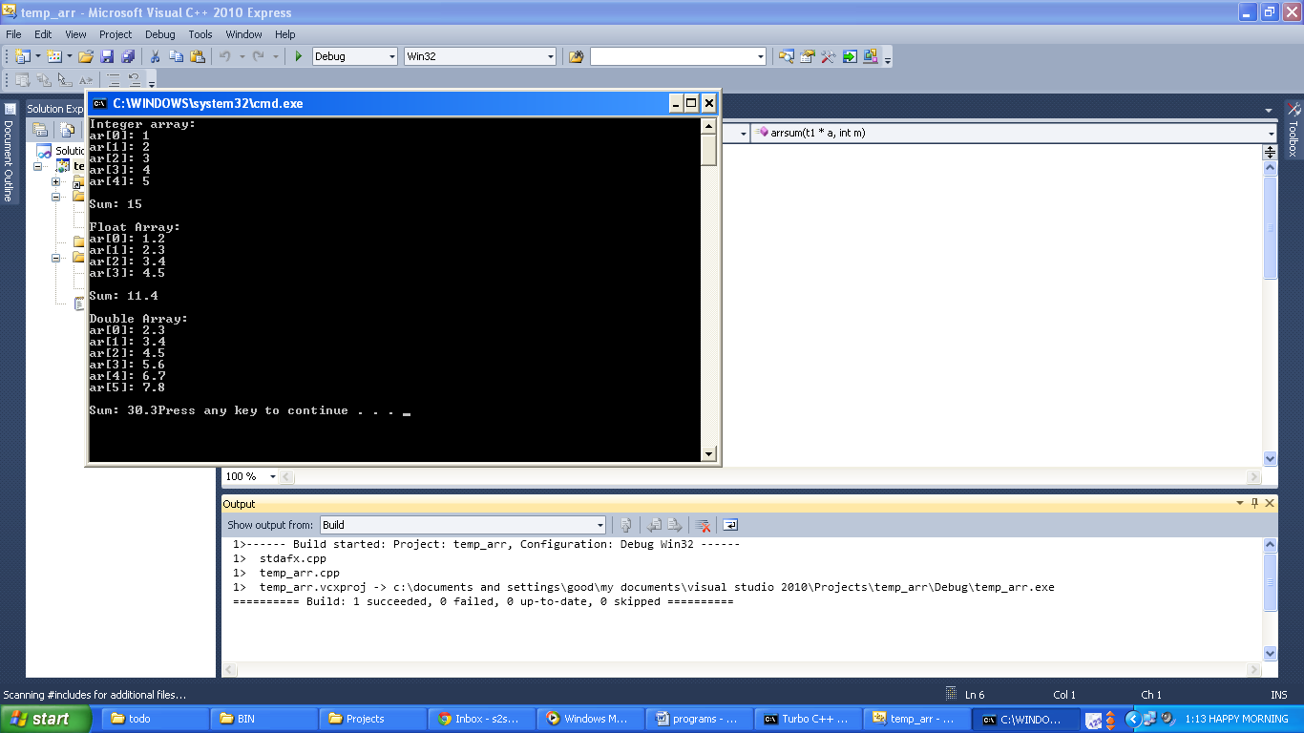

1. **Write a program to show working of copy constructor.**
   * + **Code:**

#include<iostream.h>

#include<conio.h>

class copy

{ int a,b;

public:

copy()

{ a=0; b=0; }

copy(int x,int y)

{ a=x; b=y; }

copy(copy &c)

{ a=c.a; b=c.b; }

void add(copy &d)

{ a=d.a+20;b=d.b+30; }

void disp()

{ cout<<"a:"<<a<<" b:"<<b<<"\n"; }};

void main()

{ clrscr();

copy o1(5,10),o2,o3(o1);

cout<<"Values of Object 1\n"; o1.disp();

cout<<"\n\nValues of Object 2\n"; o2.disp();

cout<<"\n\nValues of Object 3\n"; o3.disp();

o2=o1; cout<<"\n\nValues of Object 2 after change\n";

o2.disp(); o3.add(o1);

cout<<"\n\nValues of Object 3 after add\n";

o3.disp();

}

* + - **Output:**

